|  |  |  |  |  |
| --- | --- | --- | --- | --- |
| Student Name | Amirmahdi Sarikhanifard | Student Number | | 474807620 |
| Unit Code/s & Name/s | VU23215 Test concepts and procedures for cyber security | | | |
| Cluster Name  *If applicable* | N/A | | | |
| Assessment Name | Cyber security vulnerabilities testing procedures and mitigation strategies Portfolio | Assessment Task No. | | 2 of 2 |
| Assessment Due Date | Week 8 | Date submitted | | 19 / 11 /2024 |
| Assessor Name |  | | | |
| **Student Declaration:** I declare that this assessment is my own work. Any ideas and comments made by other people have been acknowledged as references. I understand that if this statement is found to be false, it will be regarded as misconduct and will be subject to disciplinary action as outlined in the TAFE Queensland Student Rules. I understand that by emailing or submitting this assessment electronically, I agree to this Declaration in lieu of a written signature. | | | | |
| Student Signature | Amirmahdi Sarikhanifard | | Date | 18 / 11/2024 |
| **PRIVACY STATEMENT:** TAFE Queensland is collecting your personal information on this form for the purpose of assessment. In accordance with the Information Privacy Act 2009 (Qld), your personal information will only be accessed by staff employed by TAFE Queensland for the purposes of conducting assessment. Your information will not be provided to any other person or agency unless you have provided TAFE Queensland with permission, if authorised under our Privacy Policy (available at <https://tafeqld.edu.au/global/privacy-policy.html>) or disclosure is otherwise permitted or required by law. Your information will be stored securely. If you wish to access or correct any of your information, discuss how it has been managed or have a concern or complaint about the way the information has been collected, used, stored, or disclosed, please contact the TAFE Queensland Privacy Officer at [privacy@tafeqld.edu.au](mailto:privacy@tafeqld.edu.au) | | | | |

|  |  |
| --- | --- |
| **Instructions to Student** | **General Instructions:**  MidTown IT employs you as a Cyber Security Analyst/Consultant. Your task is to test cyber security vulnerabilities and propose adequate mitigation strategies for two different scenarios:   * Scenario 1 – LAB Virtualised testing environment * Scenario 2 – Use Ethical Hacking to conduct vulnerability research     Your teacher/assessor will take on the role of the Project Manager assigned to this project by MidTown IT.  Read the project documentation provided and familiarise yourself with the Project Scenario or Case Study before proceeding with portfolio tasks. Confirm anything you are not sure about the project with your manager (teacher/assessor). It is essential that you have a clear understanding of the scenario and tasks that you need to complete.  This assessment instrument requires the student to complete a project portfolio that is divided into five (5) parts:   * PART 1 - Cyber security testing methodologies and tools * PART 2 – LAB: Scenario 1 Cyber security common threats and mitigation strategies   + Activity 1: Configure the Lab Environment   + Activity 2: Use tools to identify target systems   + Activity 3: Use Wireshark to monitor, capture and analyse network traffic   + Activity 4: Analysing HTTP Conversations   + Activity 5: Performing denial of service attacks   + Activity 6: Performing Man in the Middle attacks   + Activity 7: Attacking Metasploitable-2 * PART 3 – Scenario 2: Demonstrating ethical hacking principles and procedures   + TASK 1 Ethical hacking information gathering stage   + TASK 2 – Demonstrating ethical hacking * PART 4 – Scripting for cyber security environments using Python * PART 5 – Contingency task   **Storage Devices:**   * Students are required to provide their own storage device.   **Materials Required:**   * Access to PCs and peripherals * Access to the Internet * Access to Connect (LMS) * Access to virtualised testing environment * Access to Word processing software, such as Microsoft Word * Access to special-purpose tools, equipment and materials to complete the assessment.   **Online Delivery:**   * Student to supply their own PC or laptop and peripherals and internet access * Students will require permission to install the required software * Students will require access to Microsoft Office or similar application   **Documentation:**   * MidTown IT Scenario or Case Study * LAB 1 files: VU23215_LAB_Scenario1.zip   **Assessment Criteria:**  To achieve a satisfactory result, your assessor will be looking for your ability to demonstrate the following key skills/tasks/knowledge to an acceptable industry standard. Demonstrated ability to:   * Identify cyber security application layer testing methodologies and tools * Identify application layer common vulnerabilities * Use security testing methodologies, tools and commands * Demonstrate systematic network troubleshooting * Use network monitoring, sniffing and analysis tools * Configure virtualised testing environments * Use end-to-end testing commands * Identify common threats and propose mitigation strategies * Identify Trojans, viruses and worms * Identify DoS and DDoS attacks * Identify DNS and zero-day attacks * Identify security vulnerabilities of WLANs * Define common vulnerabilities and exposure (CVE) * Carry out ethical hacking * Demonstrate basic knowledge of scripting for cyber security   Refer to the marking criteria for specific details:  VU23215_AT2_MC_TQM_V1  **Details of location:**  TAFE will provide a simulated work environment in the classroom. Research activities may be conducted in the classroom or at home.  If you are unable to attend a scheduled assessment activity, you must notify your teacher before the assessment is due and supply a doctor's certificate and approval from the team manager for an extension.  **Time restrictions:**  This assignment is designed to take place over 8 weeks or approximately 32 hours. The student is expected to attend classes as per timetable details and should be able to commit up to 3 hours per week of their own time to study or study related activities.  **Interactions:**  Teamwork skills are essential in the IT industry therefore you should work in teams to consult and collaborate on practical activities. However, each student must complete the assessment tasks individually (unless indicated).  **Level of assistance permitted:**  Staff cannot directly show students answers or solutions but support and guide them to complete tasks individually. Teachers and tutors should be available in class, and accessible by email for students working from home.  **Reasonable Adjustments:**  Reasonable adjustments are available to students for a variety of reasons, including: disability, language, literacy and numeracy (LLN) problems or extenuating circumstances. Talk to your teacher, counsellor or disability officer if you require extra support or an extension based on the conditions identified.  **Number of Attempts:**  You will receive up to two (2) attempts at this assessment task. Should your 1st attempt be unsatisfactory (U), your teacher will provide feedback and discuss the relevant sections / questions with you and will arrange a due date for the submission of your 2nd attempt. If your 2nd submission is unsatisfactory (U), or you fail to submit a 2nd attempt, you will receive an overall unsatisfactory result for this assessment task. Only one re-assessment attempt may be granted for each assessment task.  ***For more information, refer to the Student Rules.***  **Work, Health and Safety:**  The work environment should be assessed for safety prior to class. Special consideration should be taken regarding potential ICT related hazards such as tripping hazards, electromagnetic radiation, ergonomics, and posture. TAFE Queensland health and safety policies and procedures should be followed at all times. |
| **Submission details** | **Evidence Required to be Submitted:**  Insert your details on the cover page and sign the Student Declaration. Include this template with your submission.  **Submission via Connect:**  Upload a single file into Assessment 2 (AT2) Assignment Folder in Connect.  Multiple files can be compressed into a single file.  Name the file:  VU23215_AT2_Surname_Student Number  TAFE Queensland Learning Management System (Connect)  **Accessing Connect:**  Connect URL: https://connect.tafeqld.edu.au/d2l/login  Username: 9 digit student number  Password: <your password>  For password reset go to: <https://passwordreset.tafeqld.edu.au/default.aspx> |
| **Instructions to Assessor** | **Specifications of assessment:**  To be judged competent in this assessment item the student is required to demonstrate competence in all indicators shown in the marking guide.  Gather evidence to demonstrate consistent performance in conditions that are safe and replicate the workplace. Noise levels, production flow, interruptions and time variances must be typical of those experienced in the cyber security field of work and include access to:   * project requirements   Ensure that students read and familiarise themselves with the Project Scenario provided and relevant files and/or resources before attempting the assessment.  **Storage Devices:**   * Students are required to provide their own storage device.   **Materials Required:**   * Access to PCs and peripherals * Access to the Internet * Access to Connect (LMS) * Access to virtualised testing environment * Access to Word processing software, such as Microsoft Word * Access to special-purpose tools, equipment and materials to complete the assessment.   **Online Delivery:**   * Student to supply their own PC or laptop and peripherals and internet access * Students will require permission to install the required software * Students will require access to Microsoft Office or similar application   **Documentation:**   * MidTown IT Scenario or Case Study * LAB 1 files: VU23215_LAB_Scenario1.zip   **Level of Assistance Permitted:**  Teachers and tutors should be available in class, and accessible by email for students working from home. Staff cannot directly show students answers but support and guide them to complete tasks individually. Students with disability will receive reasonable adjustments.  **Interactions:**  Teamwork skills are essential in the IT industry therefore you should work in teams to consult and collaborate on practical activities. However, each student must complete the assessment tasks individually (unless indicated).  **Contingencies:**  Reasonable adjustment is available to students for a variety of reasons, including: disability, language, literacy and numeracy (LLN) problems or extenuating circumstances.  **Work, Health and Safety:**  The work environment should be assessed for safety prior to class. Special consideration should be taken regarding potential ICT related hazards such as tripping hazards, electromagnetic radiation, ergonomics, and posture. TAFE Queensland health and safety policies and procedures should be followed at all times. |
| **Note to Student** | An overview of all Assessment Tasks relevant to this unit is located in the Unit Study Guide.  If you have any question or need help regarding this assessment item please contact your teacher/tutor through email or during face-to-face sessions. |

# NOTE: PLEASE NOTE THAT ALL SKILLS AND KNOWLEDGE ACQUIRED IN THIS UNIT ARE TO BE USED ETHICALLY AND NOT FOR ANY ILLEGAL PURPOSE.

# LAB Scenarios

MidTown IT employs you as a Cyber Security Analyst/Consultant. Your task is to test cyber security vulnerabilities and propose adequate mitigation strategies for two different scenarios.

**Scenario 1 – LAB Virtualised testing environment**

In this scenario, you will configure three VMs: Kali Linux, Metasploitable-2, and Ubuntu Desktop and run a series of monitoring tools and attacks to identify vulnerabilities and propose mitigation strategies.

The monitoring/sniffing/analysis tools include:

* *nmap* and *amap* - vulnerability checking, port scanning and network mapping.
* *Wireshark* – analysis of HTTP conversations, network traffic, DoS attacks
* *arpspoof* and *dsniff* (or Ettercap) - defence tools, test with Man in the Middle attack
* *Metasploitable-2 –* used to test Samba Command Execution attack

Supporting LAB files provided: *VU23215_LAB_Scenario1.zip.*

**Scenario 2 – Using Ethical Hacking to conduct vulnerability research**

In this scenario you need to choose an organisation to conduct vulnerability research.

Your task is to gather as much information as possible about a selected system using, for example, the system’s own website, user groups/bulletin social networking sites and [www.archive.org](http://www.archive.org), among other possible sources. Your task will include:

* Search for CVEs
* Identify WLAN hardware/software vulnerabilities
* Identify zero-day DNS server attacks
* Determine heuristic-based string analysis toolsets

**PART 1 - Cyber security testing methodologies and tools**

* 1. Research at least two (2) current cyber security testing methodologies from the list provided. For each methodology selected, identify its suitability, features and complexity to learn.
* Vulnerability Scanning
* Penetration Testing
* Risk Assessment
* Security Audit
* Secure Code Review
* Security Posture Assessment

|  |  |  |  |
| --- | --- | --- | --- |
| Cyber Security Testing Methodologies | | | |
| **METHODOLOGY** | **SUITABLE FOR** | **FEATURES** | **COMPLEXITY** |
| Vulnerability Scanning | Good for organizations who seek to quickly identify and address possible vulnerabilities in the system, network, or applications. | Automated scans, fast results, regular update | Using it requires having basic knowledge of security concepts, OSI model, and familiarity with scanning tools itself also. |
| Penetration Testing | Good for organizations who are planning to simulate real-world attacks to identify and exploit vulnerabilities in their test environment. | Simulated attack with creating example malicious actors, can be handled both manual and automatic, comprehensive analysis, | It again requires a deep understanding of first security elements, techniques being used by attackers |
| **Risk Assessment** | Good for organizations when they are looking for understand and prioritize potential security risks can be happened to their system, assets and their operation. | Identifying risks, impact analysis, aiding in prioritizing, gaining strategies for mitigating, helping in continuous monitoring, | It again needs us to have an understanding of first security principles, tricks being used by attackers in an attack. Further we may need to know about standard frameworks of risk management. |
| **Security Audit** | Good for organizations when they need a comprehensive evaluation of their policies, security policies, controls, and practices ( procedures) to assure that they are compliant with regulations and lastly identifying their potential weaknesses. | Comprehensive audit, checking compliance, reports with full details, both automatic and manual, | It requires us to know how to perform both automated and manual auditing process and technique. |
|  |  |  |  |

1.2 Research the following testing tools and give a brief description of each, including their strengths and weaknesses.

* 1. Wireshark
  2. AirMagnet or Airgedon
  3. Netstumbler or Kismet
  4. Netstat
  5. Nmap

|  |  |  |  |
| --- | --- | --- | --- |
| Cyber Security Testing Tools | | | |
| **TOOLS** | **DESCRIPTION** | **STRENGTHS** | **WEAKNESSES** |
| Wireshark | It is a network protocol analyser which can capture packets and inspect them in their transportation. It can be used for network troubleshooting, analysis and also educational purposes. | Open source and free, supports a wide range of network protocols, It enables us with detailed packet analyser, and filtering. | It is can be really hard for those people have just started using it. It can be used for malicious activities, |
| AirMagnet | It is a set of tools for monitoring wireless network and then perform troubleshooting. | It enables us with a comprehensive wireless analyse and troubleshooting, user friendly, it is very effective in detecting security threats . | It can be expensive, it may requires a lot of technical prior knowledge to be gained before using it in more effective manner. |
| Netstumbler | It is a windows based tool for finding wireless LANs, ( but kismet is for linux with some additional features), | It is free and open source, It is effective in detecting wireless networks and their vulnerabilities, | Netstumbler is only available for windows, Kimset is not also available for windows. |
| Netstate | It is a tool for supervising network connections and their states, which gives us a full detailed report on active connections, | Can be used by network administrators for monitoring and later troubleshooting their network, gives us a real-time data on network connections, | Limited to a specific network environments, may not offer detailed analysis same as other tools. |
| Nmap | It is a network scanner used to discover hosts and services on network, it can create map for how they are structured. | Open source and free, it is supports a wide range of networks to discover details about it ( and also wide range of vulnerabilities to detect.) have got manual, really good for Linux | Can be too complex to new learners, It may generate a lot of network traffic, |

* 1. Identify and explain at least three (3) application layer vulnerabilities.

1. SQL Injection

SQL injection is when a query receive an input of malicious SQL code by an attacker.

This will allow attackers to modify database and gain access in some cases in order to delete or do some further actions. It can lead to data breaches, lost of data integrity and unauthorized access to the organizational data.

1. Cross-Site Scripting (XSS)

Cross site Scripting is where we have got malicious scripts injected into organizations’ web pages by attackers, disrupting webpages operations sometimes but in other occasions they do perform just unauthorized access to steal sensitive information from web pages and its users. It can further lead to identity theft, and unauthorized access to user accounts.

1. Insecure Direct Object References (IDOR)

IDOR is when direct access is being provided to objects ( like files or database records) by an application based on user-supplied input. Attackers can use this to gain unauthorized access to data, and manipulation and potential data breaches.

* 1. Identify three (3) policies that can be used to minimise application layer vulnerabilities. Review and explain each policy.

1. Secure Coding Practices

When we are developing the software in a process, we are supposed to have secured coding practices implemented to prevent vulnerabilities from even being introduces. It includes defining valid inputs ( those can not be used with codes and scripts to defeat the security), sanitizing output and preventing any other common security misdeeds. In this way, we will be able to reduce the number of vulnerabilities in the code, leading us have a more secure application. So developers are required to be trained with secure coding techniques and methods in addition to guiding them throughout the project with good organizational coding procedures and policies.

1. Regular Security Audits and Code Reviews

This policy can be periodically implemented to have codes and coding procedures reviewed to identify and fix possible vulnerabilities. This Audit policy can be conducted for both internal technicians and also any possible external experts who are aiding internal staffs. This can be part of development lifecycle, but it can be also an additional audit. It will be helpful to catch vulnerabilities early, assuring they can be mitigated before deployment.

1. Secure Configuration Management Policy

The policy mentioned is about ensuring about the software application those operating on the application layer has been configured securely based on the provided guidelines and policies. It should be along with regular reviews and updates to configuration settings. This will benefit us in prevent of any misconfigurations which can be later source of new vulnerabilities.

* 1. Identify and explain at least three (3) physical vulnerabilities of the WLAN

1. Unauthorized Access Points

Aps can be implemented by attackers or internal actors without prior authorization. This Access points can be used to intercept network traffic which can lead to data breach, unauthorized access and possible network disruptions.

1. Physical Theft of network devices

Wireless devices and even access points can be stolen physically which can lead to breach of data stored in those devices, and further Can disrupt network operation. In some occasions, identity theft can also occur.

1. Environmental factors

Sometimes lack of modern devices those can adapt themselves into different environmental conditions such as extreme temperature or humidity which can impact the performances and reliability of WLAN hardware. This can cause downtime, data lose, and also rise of operational costs.

1.6 Identify current frameworks that can be used to identify application layer vulnerabilities.

1. NIST Special Publication 800-53

This framework may not fully focus on the application layer but it still contains controls those can be helpful in identifying and mitigating such vulnerabilities at application layer.

1. OWASP Top 10

It is a framework usually given to organizational developer and web security experts to aware them about possible vulnerabilities and helping them preventing them before occurring. It also aids experts to find a way for mitigating them after identifying them. It provides a full detail guide towards a better understanding of the methods can be implemented while completing the application and even when it is being used to keep their operation safe at this layer.

1. Secure Software Development Framework

SSDF which is also known as NIST SP 800-218, it is a framework which is enabling us with best software development practices in term of security to be implemented in the software development life cycle. It will be helpful in identifying and addressing vulnerabilities early while developing them. It enables us to have structured approach to secure this layer.

**PART 2 – LAB: Scenario 1 Cyber security common threats and mitigation strategies**

The supporting lab files in *VU23215_LAB_Scenario1.7z* can be followed.

# Activity 1: Configure the Lab Environment

2.1 Complete the activities in the first set of lab notes for this unit to configure the lab environment and configure the network settings for three of the four virtual machines (VMs) in the lab environment. The three VMs you need to configure are Kali Linux, Metasploitable, and Ubuntu Desktop. They should be configured to have the logical network connectivity as shown in this diagram:

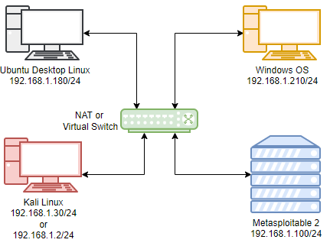

© TAFE Queensland 2022. Icons © draw.io

Note: any lightweight Linux OS can be used instead of Ubuntu Desktop, such as:

1. Linux Mint
2. Xubuntu
3. Lubuntu
4. Debian Distro
5. Ubuntu 14.04
6. Ubuntu Server with LXDE desktop environment
7. Provide the full pathname of the configuration file where the network settings for Kali Linux and Metasploitable are stored.

For Kali Linux :

/etc/network/interfaces

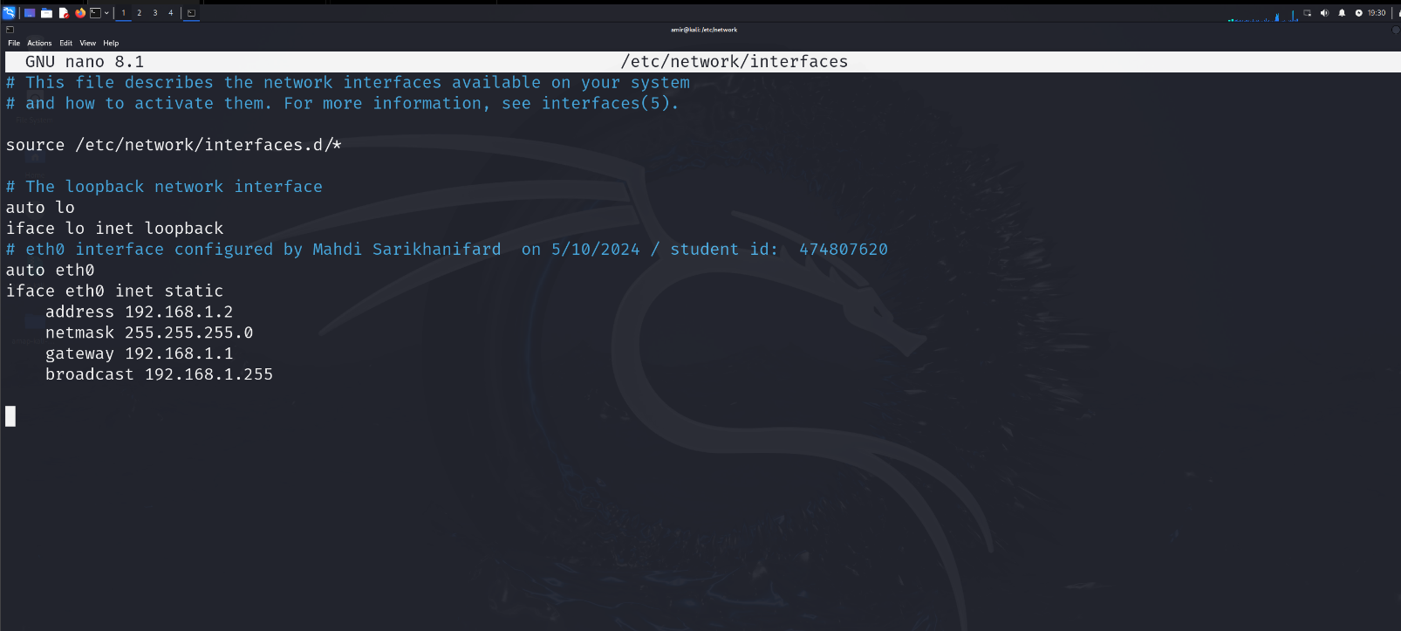

For Metasploitable, :

/etc/sysconfig/network-scripts/ifcfg-eth0

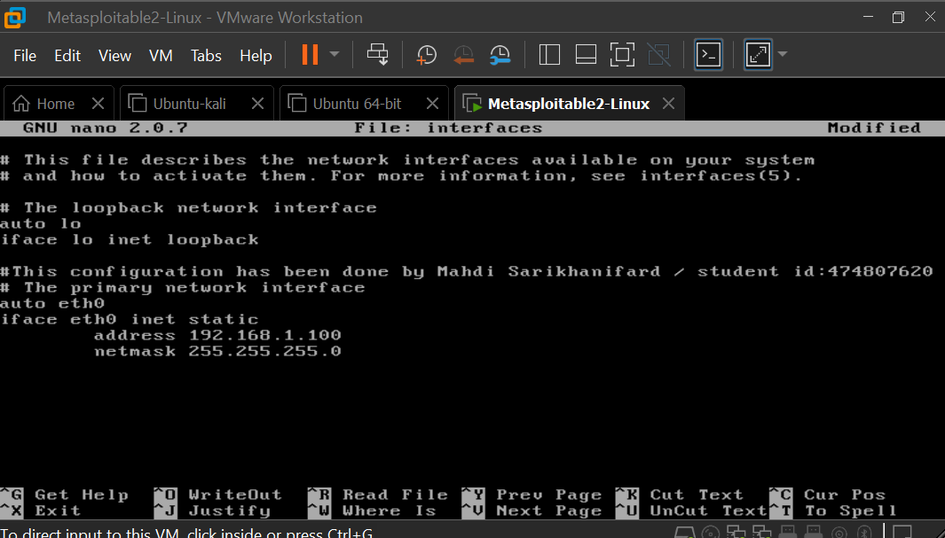

1. Include a screenshot of the contents of this file from your Kali Linux system and a screenshot of the contents of this file from your Metasploitable system. Make sure that the contents of the file include your name and the date you edited the file.

Provided.

1. Include a screenshot of the output of a command line network command from *both* Kali Linux *and* Metasploitable showing the actual IP address and netmask on their network interfaces.

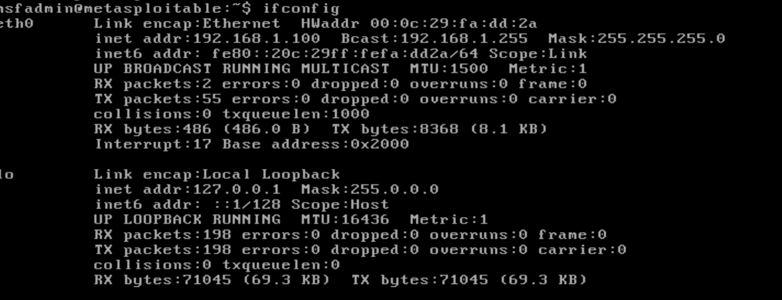

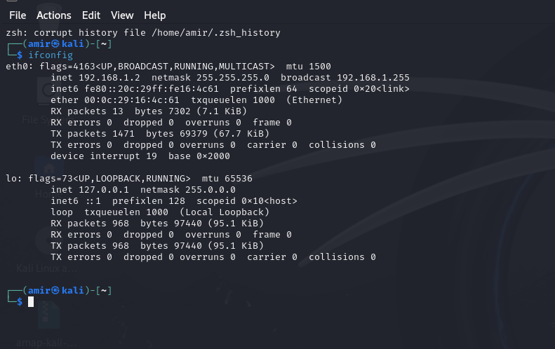

1. Include a screenshot of the contents of the network configuration file from your Ubuntu system. Make sure the contents of the file include your name and the date you edited the file.

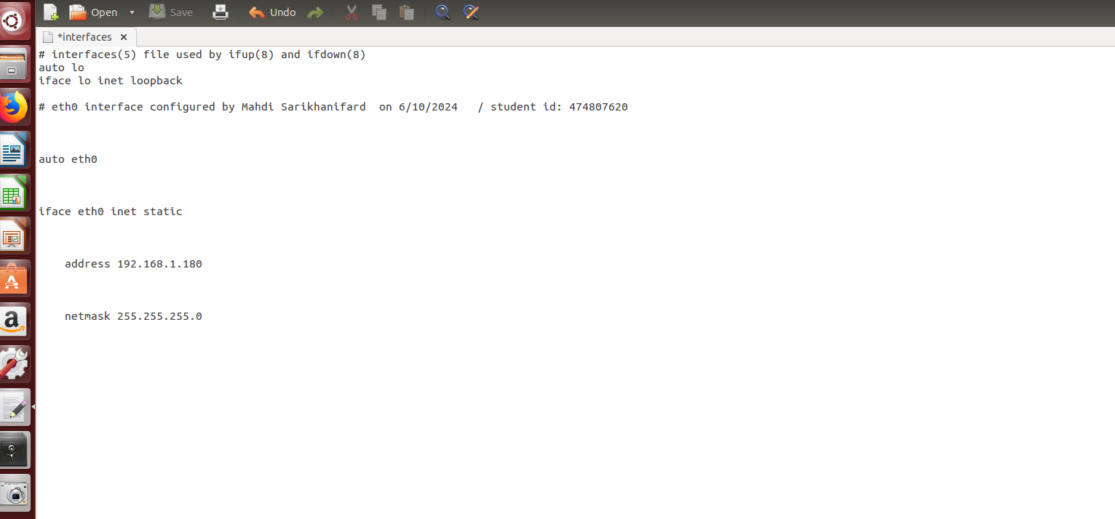

1. Include a screenshot of the output of a command line network command from the Ubuntu desktop showing the current IP address and netmask on your network interface.

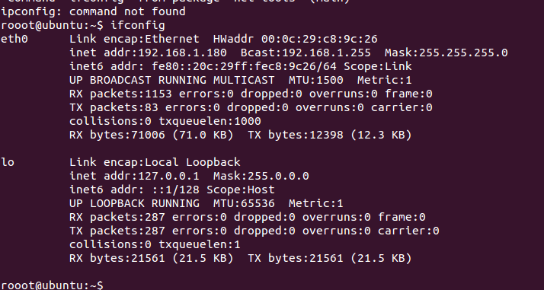

1. Include a screenshot of a series of ping network commands on one of the three systems to check that there is an end-to-end network connection between that system and the other two systems. Your screenshot must show the IP addresses of all three systems: Kali, Metasploitable, and Ubuntu.

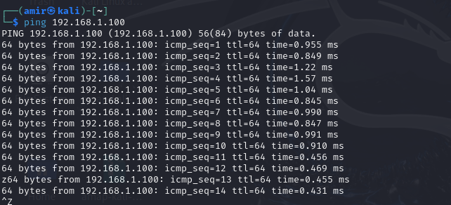

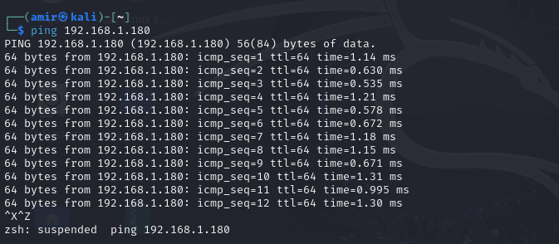

1. Write a summary of the steps you would take to troubleshoot basic network connectivity on the network. Please organise your answer, which could be related as a systematic approach, to be useful to other peers in the IT field. In your summary, include layer three test commands for ping and traceroute. Add other commands as necessary and explain the importance of such commands.

A systematic approach for troubleshooting of basic network connectivity:

1. Verify Physical Connection

* Check cables and connections: In order to ensure all cables are connected in a correct and secure manner preventing any damage.
* Inspect Network interfaces: We need to assure all network devices such as switches and hubs are functioning and powered on.

1. Check network Interface Configuration

* Command for Linux will be “ ifconfig” but for windows will be “ipconfig”.
* Purpose: This will aid us having an overview of network interface configuration. In this way, we will be able to assure about device having a valid IP address along with subnet mask, and gateway.
* “Note”: You might be able to look up network interface files in most Linux versions but mentioned previous approach seems to be much faster and most often accurate.

1. Test both Local and External Network Connectivity

* Command: ping <the IP address of target>
* Purpose: It is going to test connectivity of targeted interface to the one we are pinging on. If the ping was successful, it indicates the connectivity. This will be the same for the external network connectivity but the only difference is that we ping those hosts are located in external location.

1. Trace the network Path:

* We are able to trace route in both Linux and Windows in order to trace the path packets take to the target.
* For Linux: traceroute <IP address or hostname> , For Windows : tracert <IP address or hostname>
* In this way, we will be able to analysis delays or failings in the path.

1. Review Network Logs:

* Check interfaces logs: Review logs on the routers, switches, and firewalls in order to learn about possible error messages or any unauthorized or unusual activity.

1. Update and Patch

* Update Firmware: we need to assure routers, switches and other network interfaces have the latest firmware.
* Updating Drivers: We need to verify that drivers at the network interfaces are up to date on all devices.

1. Advanced Diagnostic

* Use network diagnostic tools: There are some tools such as Wireshark which may usually considered as a learning tool, but it can still help us in the process of analysing the packets to check how they do function in the their path

**Activity 2: Using tools to identify target systems**

2.2 Complete the activities in the second set of lab notes for this unit to use the *nmap* and *amap* tools to identify potential target systems and their characteristics.

Complete the following table to describe the purpose of the given **nmap** command line options:

|  |  |
| --- | --- |
| NMAP OPTION | PURPOSE OF THIS OPTION |
| **-sT** | Performing TCP connection in order to discover all open ports |
| **-F** | Performing fast scan to provide a quick overview of the target ( Network) , it will skip detailed report. |
| **-A** | Performing aggressive scan to received detailed scan of the network including ports, services, and also host scripts and details about operating system. |
| **-sC** | Performing a default script scan to check vulnerabilities. Similar to the -A but talking more time making accurate. |
| **-PU** | Performing UDP connection to discover ports , which sends a UDP packet to the targeted ports. It is not detailed too much. |

1. Include a screenshot of the output of this *nmap* command run from your Kali Linux system:

**nmap -sT 192.168.1.100**

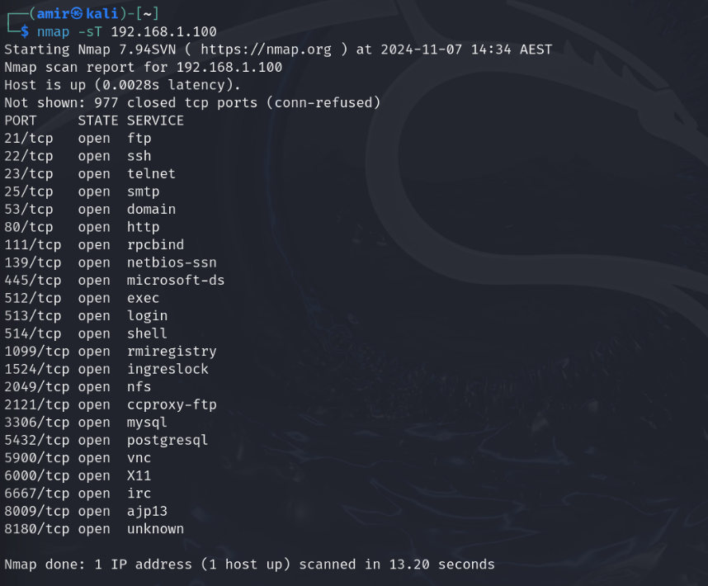

1. Write a paragraph describing what information this command gives you about the system with the IP address 192.168.1.100?

As soon as I run the command it starts its search, and after a brief delay ( subject to change) I firstly will be able to see if the host is up, and check how many ports are not available. After that we will have open ports with TCP connection including services for each one of them.

1. Attach a screenshot of the output of the **nmap -sT** command executed from your Kali Linux system to your Ubuntu system:

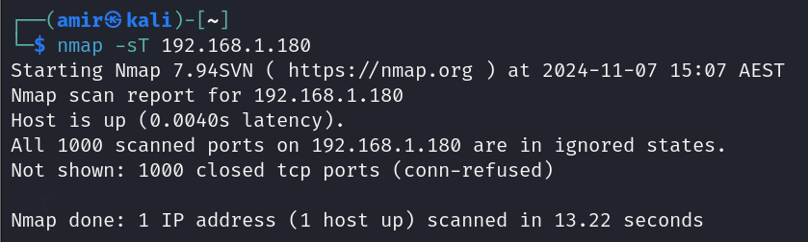

1. Answer the following question: What information in the *nmap* output gives you the impression that Ubuntu is a client desktop system while Metasploitable is a server system?

The information given to us about Metasploitable containing many open ports with dedicated services indicates that Metasploitable is being used as a server system. At the same time, given information about Ubuntu doesn’t reveals any available (open) ports which indicates that this host has been dedicated as a client desktop.

1. Include a screenshot of using **nmap** with these command line options (one at a time) to scan your Metasploitable system:

* **-F**

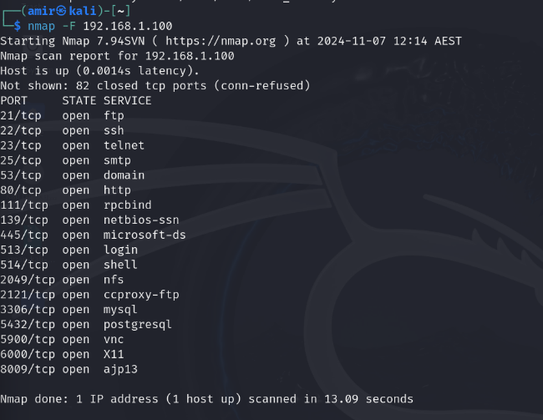

* **-A**

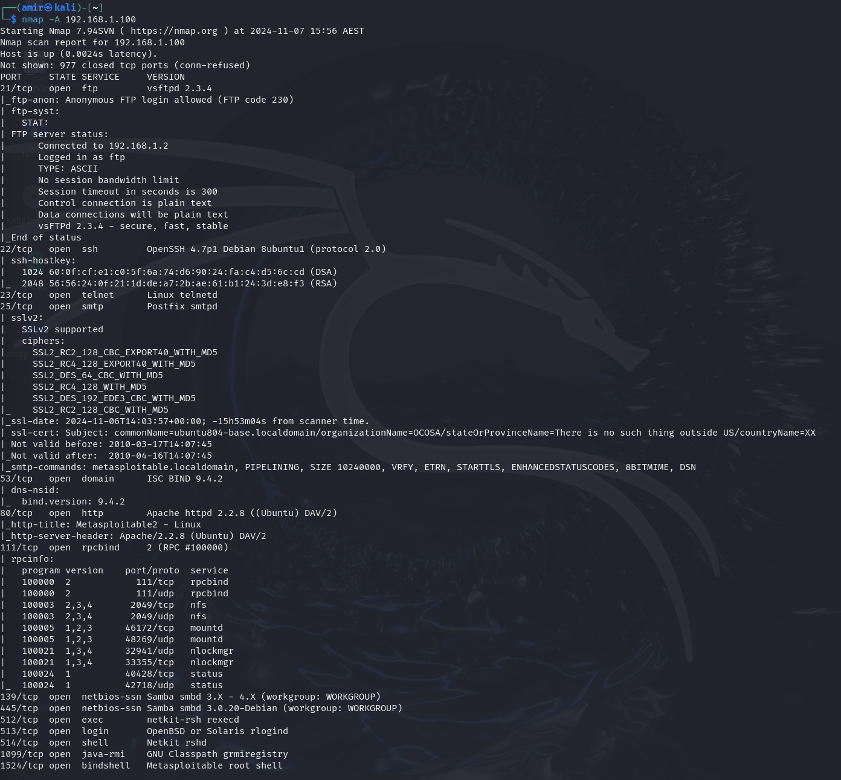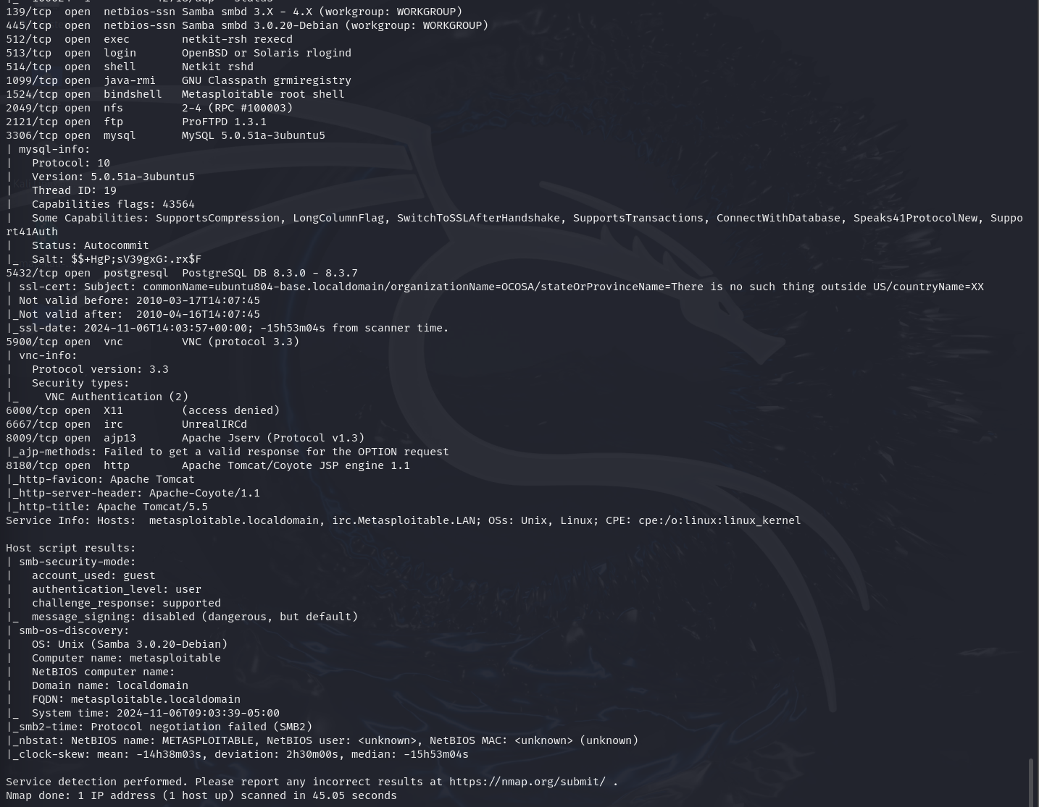

* **-sC**

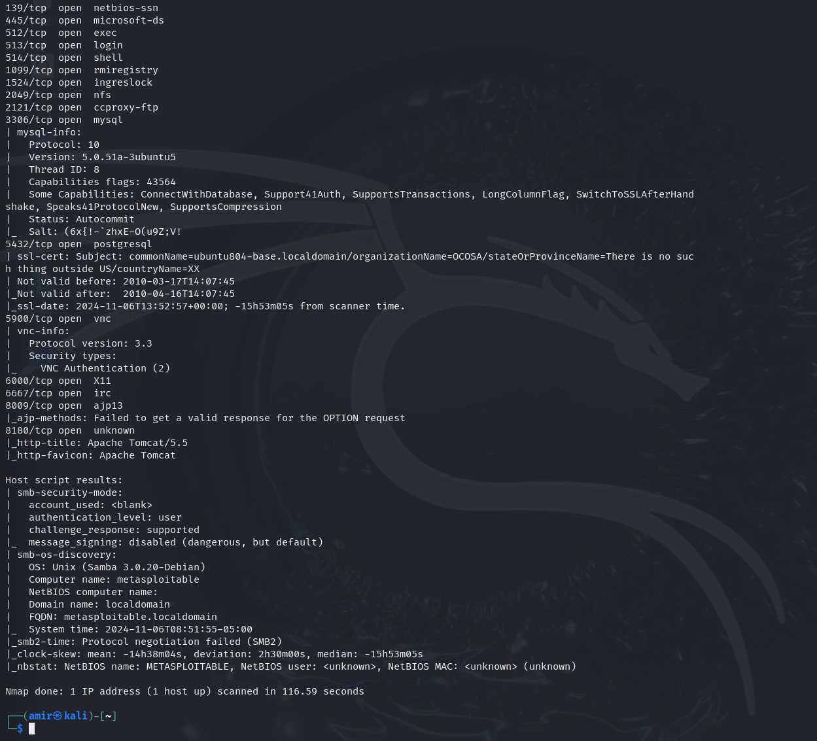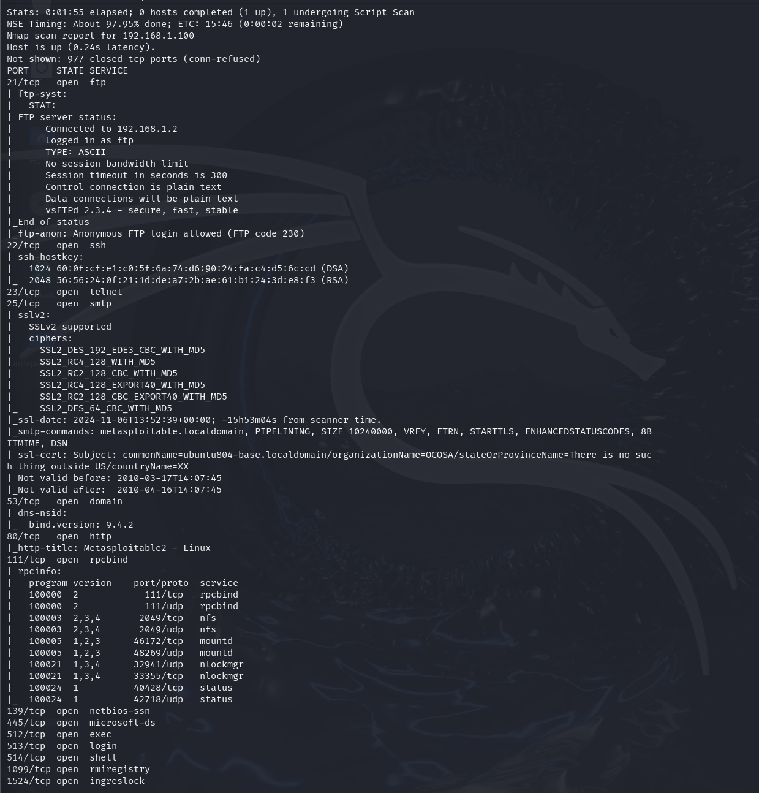

* **-PU**

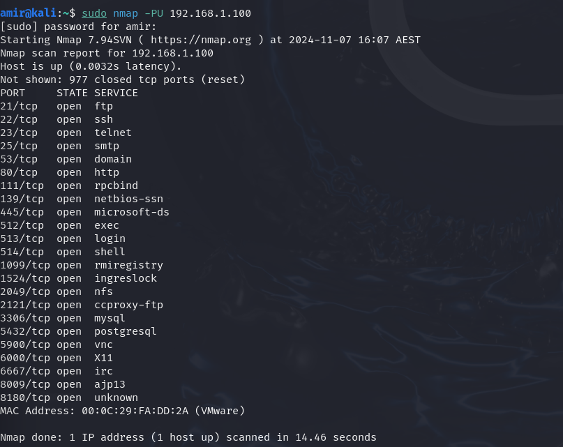

1. Answer the following question: What output information for Metasploitable does each of these *nmap* options give that the other options do not?

In all of these screenshots, it is obvious that Metasploitable is one of operating systems which are vulnerable in default way as these open ports can be also services those are being used for a purpose.

1. Include a screenshot of the **amap** tool retrieving the banner from TCP port 22 on your Metasploitable system.

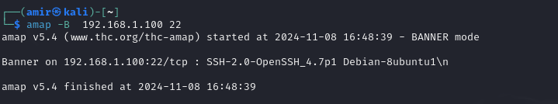

1. Answer the following two questions:
   1. What Application Protocol is running on TCP port 22 on your Metasploitable system?

Seems like having ssh service is being used.

* 1. What software and software version is running on TCP port 22 on your Metasploitable system?

SSH 2.0-OpenSSH 4.7p1

1. Answer this question: Explain the ethical hacking principle that says you should only use the *nmap* and *amap* tools on networks that you have permission to use, or on networks that you control.

The ethical hacking principle is being used to aware us that before using tools such as Nmap and Amap which can affect operation of a network and also reveal sensitive data of an organization, we need to have the permission otherwise we can face serious legal consequences ( sometimes because of possible damages to the network facilities of that organization). So we need to seek consent, respect privacy while scanning to prevent legal implications and potential damages while scanning.

**Activity 3: Use Wireshark to monitor, capture, and analyse network traffic**

2.3 Use the Wireshark network sniffing tool to analyse the captured network traffic in the *TCP_Example.cap* file provided in the lab environment for this unit. Do not apply any display filters to the traffic. Answer the following questions about this traffic:

1. What TCP port is the web client using in the HTTP conversation?

Port 54841 (Source port)

1. Based on the content of the HTTP conversation, what operating system is the client running and what web browsing software is it using?

Linux operating system is the operating on the client, specifically Ubuntu 10.04 (Lucid) Firefox/3.6.3.

1. Is it the client or the server that initiates the closing of the TCP connection in the HTTP conversation?

That is the server who initiates the closing of the TCP connection.

* + - * 1. What evidence in the captured traffic leads you to this conclusion?

The flag was FIN ACK means that the source is the one who signalling that it has finished sending data and wishes to close the connection. Source port in this packet was 54841 and destination port was 80 which the communication is based on HTTP traffic.

2.4 Using the Wireshark network sniffing tool, analyse the network traffic captured in the *UDP_Example.pcapng* file provided in the lab environment for this unit. Answer the following questions about this traffic:

1. Describe how you would filter and display only the UDP traffic in the captured traffic.

I searched for the UDP in the above filter bar to only see this type of connections.

1. Describe how you would display the contents of UDP packet #1169 in the captured traffic.

First of all, I find the targeted packet, then double click on it and then expanded the User Datagram Protocol.. and then click on the UDP payload (38 bytes) to reveal content of this UDP packet.

1. What DNS request is the client making in UDP packet #1169?

www.directory.gov.au

1. Based on your traffic analysis, what is the response to the DNS request in UDP packet #1169?

The response given to the 1169 is on the packet 1199.

# Activity 4: Analysing HTTP conversations

2.5 Complete the activities in the fourth set of lab notes for this unit to use the Wireshark tool to capture and analyse HTTP network conversations.

1. Insert a screenshot showing the three packets in the three-way TCP opening handshake from the web client on Kali Linux to the IIS web server on Windows.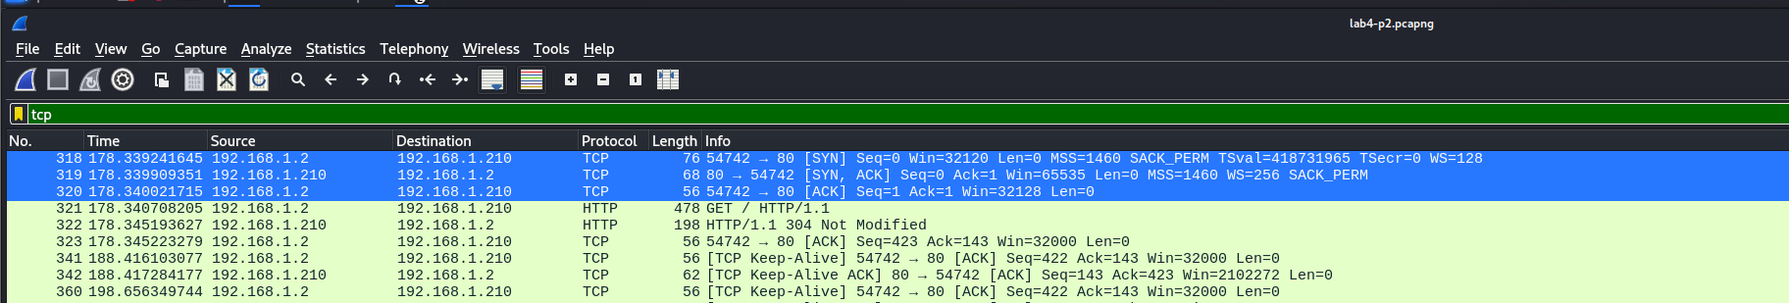
2. Describe which TCP flags are turned on in each of the three handshake packets and why these TCP flags are turned on.

So there are three packets in this handshake. First one’s is SYN flag which is trying to establish connection by its initial sequence number. The second packet flags are SYN and ACK. The SYN and ACK together acknowledges the sent SYN request by client, aware it is also ready to establish connection by providing its own sequence number. Lastly, third packet flag is ACK which sent back to the server to acknowledge the receipt of the server’s SYN-ACK. Now the connection has been fully established and data is transmittable.

1. Insert a screenshot showing the three packets in the three-way TCP closing handshake.



1. Describe which TCP flags are turned on in each of the three closing handshake packets, and why these TCP flags are turned on.

Again, we have got three packets, first one flag is FIN- ACK to alarm about connection closure by sending a FIN packet, and then ACK flag at the same packet to acknowledge receipt of last data from the server. Then we have got second packet. This packet is containing response of Server with flag of its own FIN. Further it also contains ACK again to acknowledge the client’s FIN in last packet. Lastly, we have got third packet with flag of ACK, it indicates it is it is final ACK packet sent by client to confirm receipt of the server’s given FIN in last packet.

1. Insert a screenshot of the HTTP conversation showing the three client requests to retrieve three documents from the IIS web server.

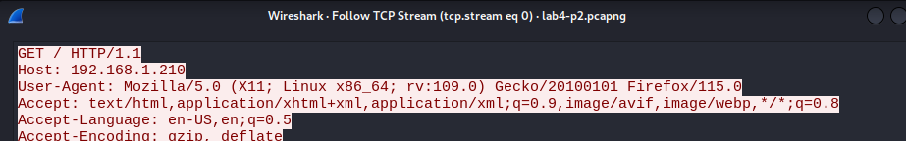

1. Using the information from the screenshot earlier, describe what types of documents were sent from the web server to the web client.

Text for base of HTML, application using XHTML + xml, application using xml;q=0.9 saying that client accepts XML but not strongly as HTML or XHTML, then image/avif avif as the image format which is modern providing high quality and compression, image/webp is also a modern image format.

1. Insert a screenshot of the HTTP conversation from the Windows web client to the Apache web server

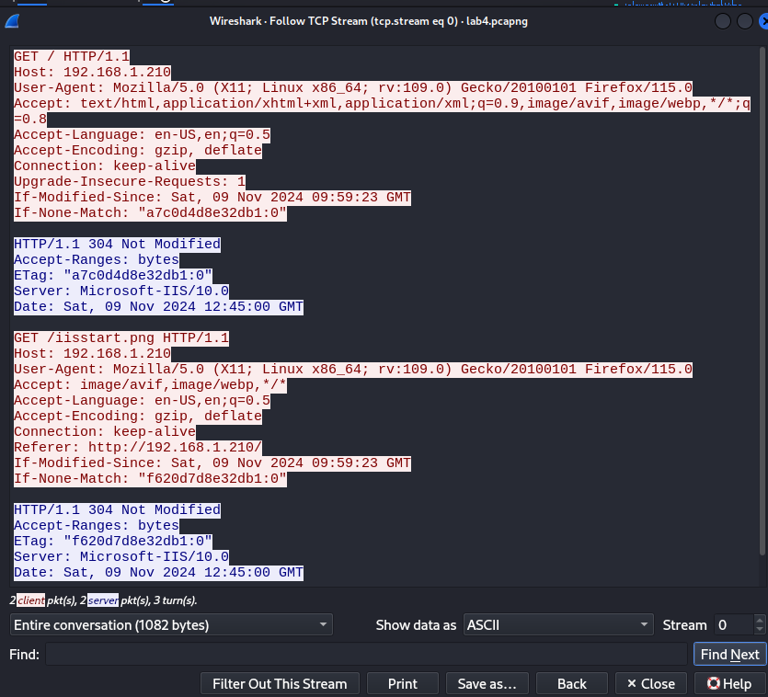

1. Using the information from the screenshot earlier, describe what web server software, version, and operating system name the web server is displaying to the web client.

Web server software: Microsoft-IIS

Version: 10.0

Operating server has not been mentioned directly but possible to guess but can’t be trustful.

**Activity 5: Performing denial of service attacks**

2.6 This activity can be carried out using either the fifth lab for Telnet/SSH analysis or the FTP/FTPS lab.

1. Include a screenshot of the Telnet Application Layer conversation (or FTP) between Kali Linux as the client VM and the Windows system as the server VM.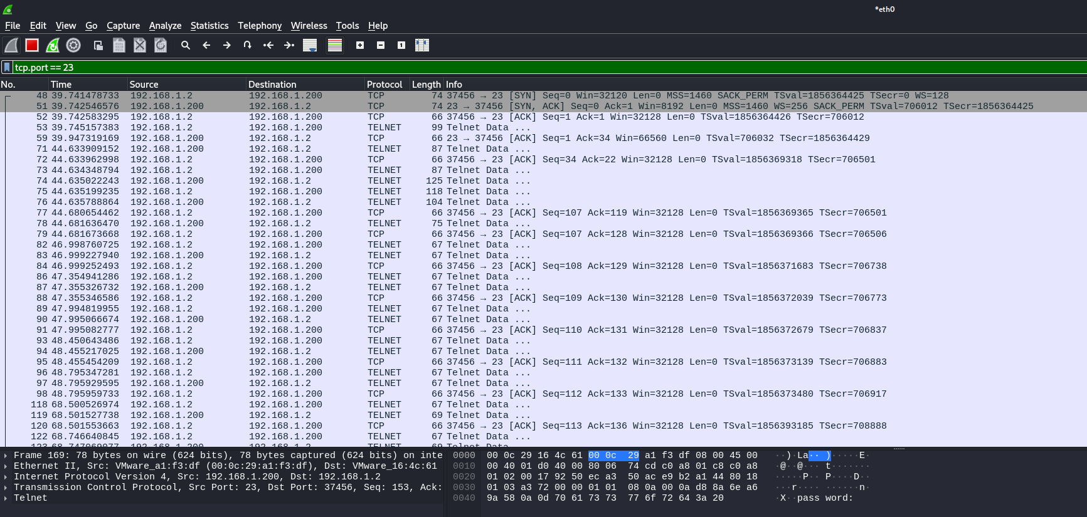
2. Answer the following two questions:
   1. What sensitive information was sent from the Telnet client or FTP client to the server in clear/plain text (i.e. unencrypted)? I was able to see the username and password easily and lots of more details those was streaming.
   2. Explain why this is a security risk if a third party was able to sniff the network traffic.

As the conversation is not encrypted, other parties can easily get easily aware of that conversation. It can lead to credential theft, unauthorized access, data integrity compromise, and lastly reputation damage.

1. After using Wireshark to capture the SSH or FTPS conversation on your Kali Linux system, answer the following questions:
   1. Can you see the username or password being sent from the SSH or FTPS client to the SSH or FTPS server in the clear? Yes I can see them.
   2. Explain how this makes the SSH or FTPS protocol a lesser security risk than the Telnet or FTP protocols.

So we know that both Telnet and SSH are containing our username and password in their conversation, in this case when there is a usage of one of those, it should be better to implement SSH cause of its encrypted communication preventing to monitor sensitive data clearly.

1. Include a screenshot showing the open TCP ports on your Windows system, with your name in the screenshot.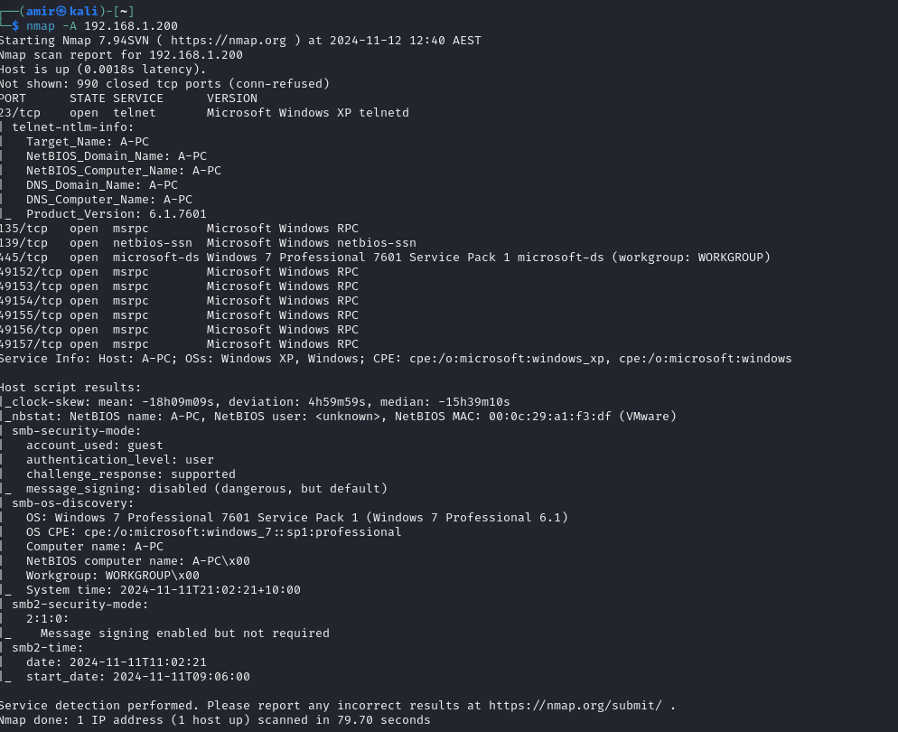
2. Include a screenshot of the output of the “dos.py” denial of service script as it attacks your Windows system, with your name in the screenshot.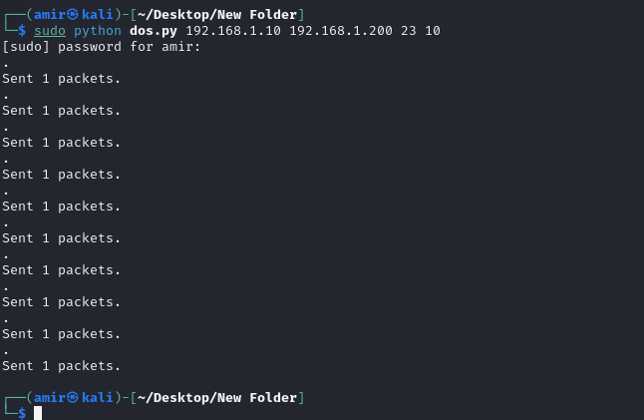
3. Include a screenshot of the ten TCP SYN packets sent in the DoS attack, with details of the TCP fields shown.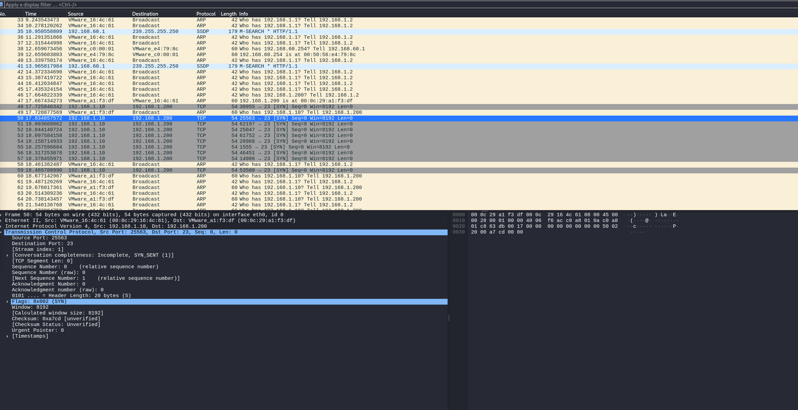
4. Answer these questions: In the packet in the screenshot earlier, what are the values for the:
   1. Sequence number : 0
   2. Windows size: 8192
   3. TCP segment length : 0
5. After running the “ettercap” denial of service attack on your Windows system, paste in a screenshot of some of the attack packets that are SYN packets sent from the spoofed IP address.

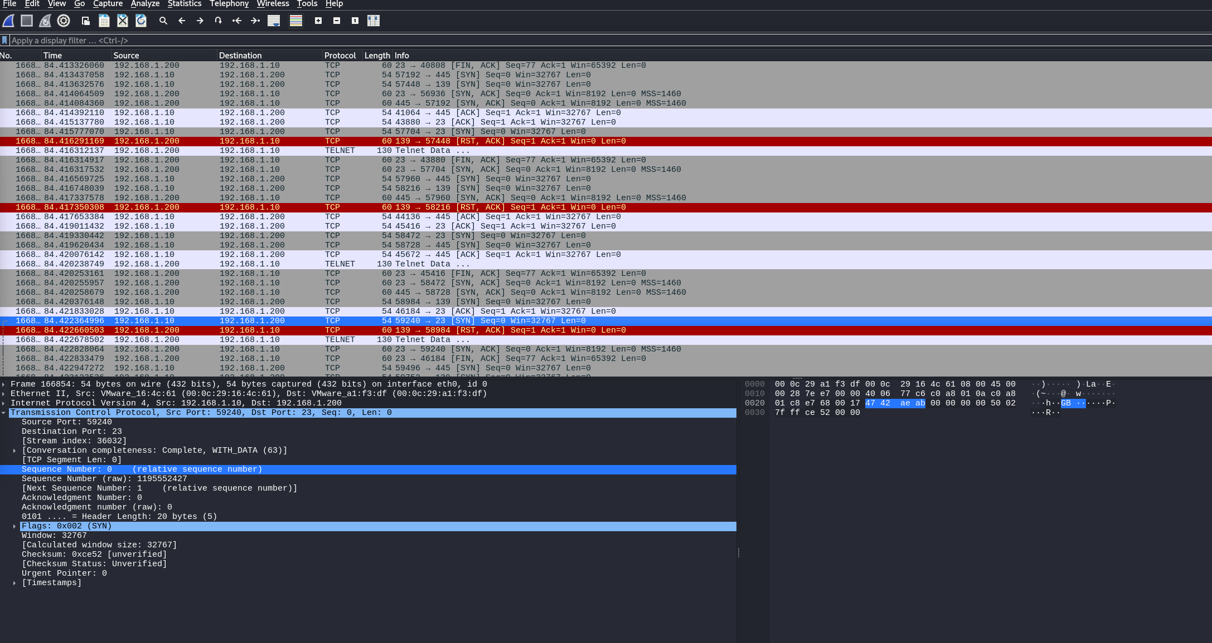

1. Describe at least three ways to mitigate TCP SYN denial of service attacks against a system. Write at least one paragraph for each mitigation technique.
   1. SYN Cookies

SYN Cookies are methods implemented in order to prevent SYN flood attacks by making server no longer sneed to maintain state information for half-open connections. When a SYN request is received, the server needs to generate a cryptographic cookie and sends it back to the client in the SYN-ACK packet. Then the client requires to return this cookie in form of the ACK packet to complete the handshake. In this manner, attacker will not be able to predict the cookie value. But I do believe this may fail if scripts in use get more complex.

* 1. Increase Backlog Queue

By enlarging the backlog queue capacity, a server will be more likely able to handle a large number of incoming SYN requests before it begins dropping them. It will provide a defence against flooding attempts, enabling the server with more accommodation for half-open connections. But it always is not the best option as delays the main traffic.

* 1. TCP Intercept

There are some routers, and firewalls featuring TCP intercept which enables us to mitigate SYN flood attacks by supervising the rate of SYN packets and further can perform intervention in the TCP communication in necessary cases. This can be implemented in two models of Intercept mode and Observation mode. Using this method, we will be able to minimize the quantity of incomplete TCP connections and protects the server from being a traffic hub of unwanted packets.

1. Write the meaning of the terms “RFC documents” and “BCP documents”.

**RFC documents**

Firstly, RFC stands for the request for Comments. Such documents are a collection of developed memoranda containing recent research, innovations and developing methodologies associated with different subjects of internet and networking technologies aiding technicians in diverse processes. Nowadays, we have got IETF who is using RFC documents for introducing protocols, procedures and standards on the internet, which involves contribution of a diversity of experts around world. These documents will be essential in process of mitigation and advancement of interoperability of the internet. There are many cases where RFC documents get converted to standards after decades of development.

**BCP Documents**

**F**irst of all, BCP stands for Best Current Practices. Usually, these documents are similarly being published by IETF, enabling experts with best guidelines, recommendations, and best practices for communities those who are professionally involved with internet and networking. In contrast to the RFC, BCP documents concentrate on operational procedures and practices that believed to be most effective ones compared to other ones being used. In overall, they are being keep up to date in order to offer practical advice across various organizations and users based on the reflected current needs.

1. Identify an RFC document and a BCP document that deal with DoS mitigation.
   * 1. RFC 8612 | DDoS Open Threat Signalling (DOTS) Requirements
     2. BCP 38 | Network Ingress Filtering: Defeating Denial of Service Attacks which employ IP Source Address Spoofing

# Activity 6: Performing Man-in-the-Middle attacks

2.7 Complete the activities in the sixth set of lab notes for this unit to use the *arpspoof* and *dsniff* (or *Ettercap*) tools to perform a man-in-the-middle attack.

1. Answer the following question in your own words: Explain how *arpspoof* or *Ettercap* fools a client and server into thinking they are still communicating directly when they are not. In your answer, identify which layer of the OSI model is involved.

We have got arpspoof which is able to intercept and monitor network traffic between two devices, simply by spoofing or in other words fake ARP (Address resolution Protocol) replies. In this manner, it will be able to redirect traffic which suppose to directly approach one device to another device( most often attackers device.) Basically, on a network, we can observe that devices are communicating with each other by sending packets among them which contains MAC addresses. So if there is a switch it will use the same logic and will forward traffic to the correct device based on the MAC addresses. So attackers can implement arpspoof in order to send out fake ARP replies indicating that their MAC address is the one associated with targeted device or gateway. Finally, the switch or other interface will be tricked and send the traffic to the attacker’s device instead of the planned device. The ARP is operating at layer 2 , the Data Link Layer of the OSI model.

1. Once you have *arpspoof* or *Ettercap* targeting both your Ubuntu and Windows systems, add a screenshot showing a successful ping from Ubuntu to Windows, a successful ping from Ubuntu to Kali Linux, and the ARP table on Ubuntu. 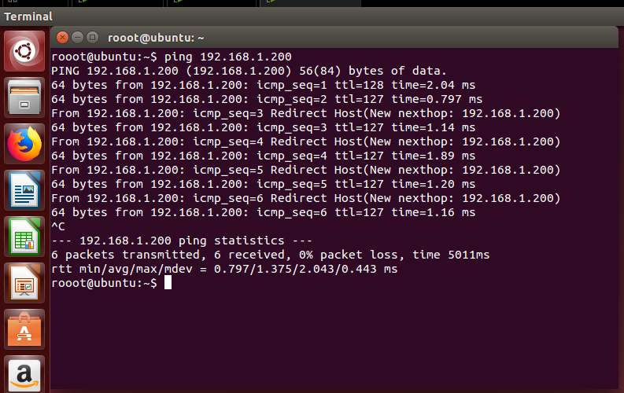

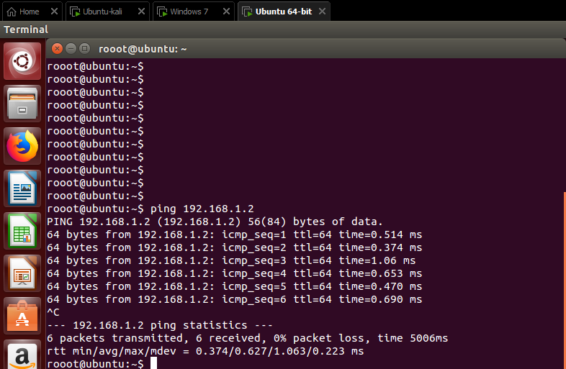

1. Explain how the information in the ARP table above indicates that an ARP spoofing attack is in progress.

Even thought we can see that we receive “From 192.168.1.200”, but as there a suggestion at the end of packet saying that “Redirect Host(New nexthop: 192.168.1.200)” means that the 192.168.1.200 is the fake one and might be changed by the Kali linux ( where we have put same MAC for both).

1. Include a screenshot showing a successful ping from Windows to Ubuntu, a successful ping from Windows to Kali Linux, and the ARP table on Windows.

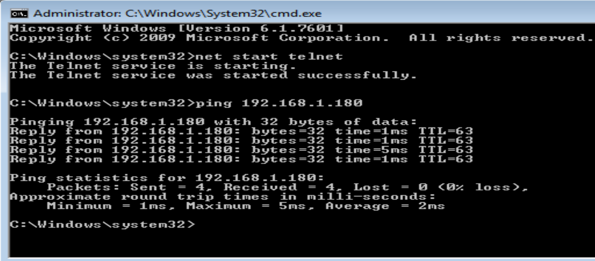

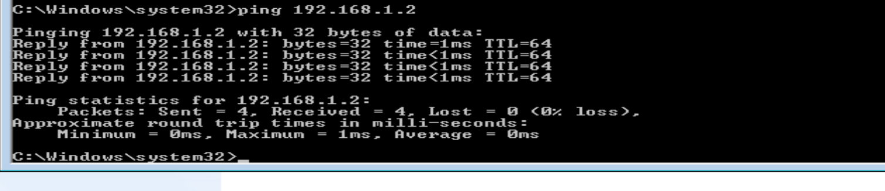

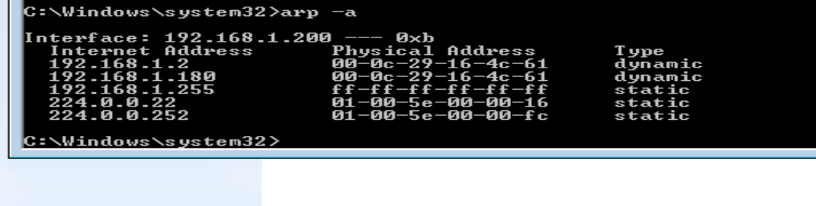

1. Once you have captured HTTP packets on the man-in-the-middle system, paste a screenshot of some of these HTTP packets involved in the conversation between Ubuntu and Windows 10 to confirm that Kali Linux is the man-in-the-middle of the conversation. The screenshot must show HTTP packets with the IP addresses of both the Ubuntu and Windows systems.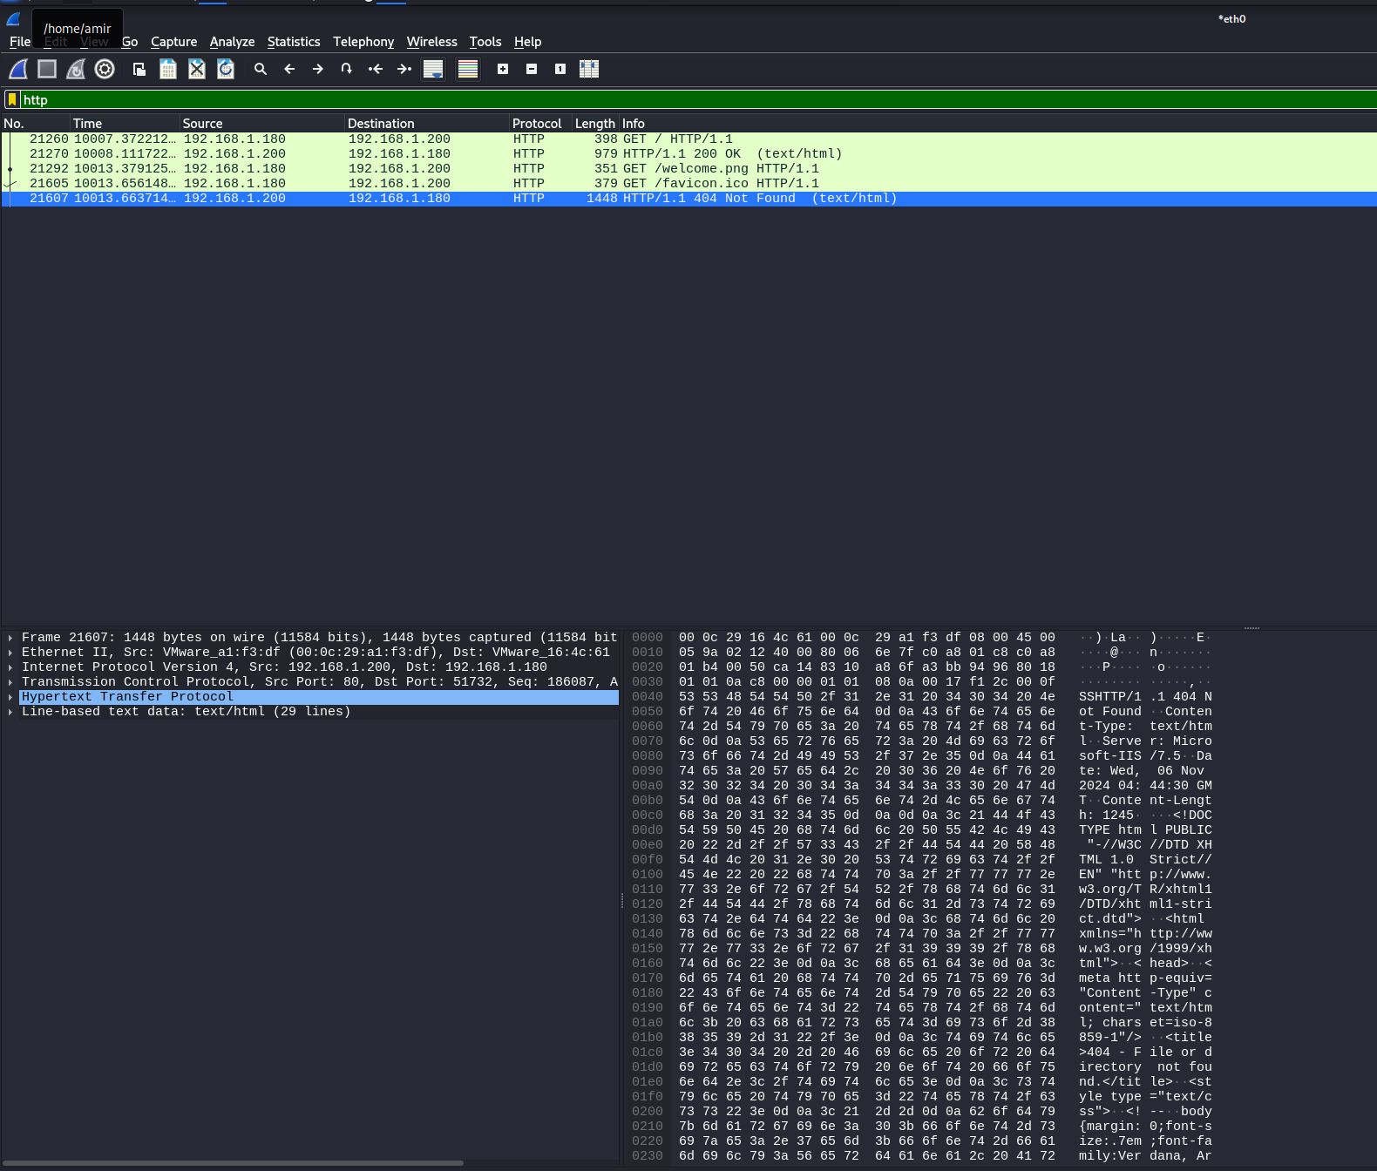
2. Explain in your own words what *dsniff* or *Ettercap* can do and which Application Layer protocols it understands.

Dsniff is a additional tool which we can use while monitoring and analysing the network traffic. Based on the manual, it is concentrating primarily on password sniffing and man in the middle attacks. It will enables us attackers to to capture sensitive information, especially unencrypted data being transferred between two devices. As I found in the dsniff manual, it has got different tools designed to capture and affect network packets, specifically as mentioned demonstrating the insecurity of cleartext protocols. It allows us (or attackers) to intercept traffic and find out about sensitive data such as credentials.

Dsniff can handle HTTP, FTP, Telnet, SMTP, POP3, IMAP, SMB and more

1. Include a screenshot of the output from the *dsniff* or *Ettercap* command or interface where it has captured sensitive information via a man-in-the-middle attack, and write an explanation of what you see in this output.

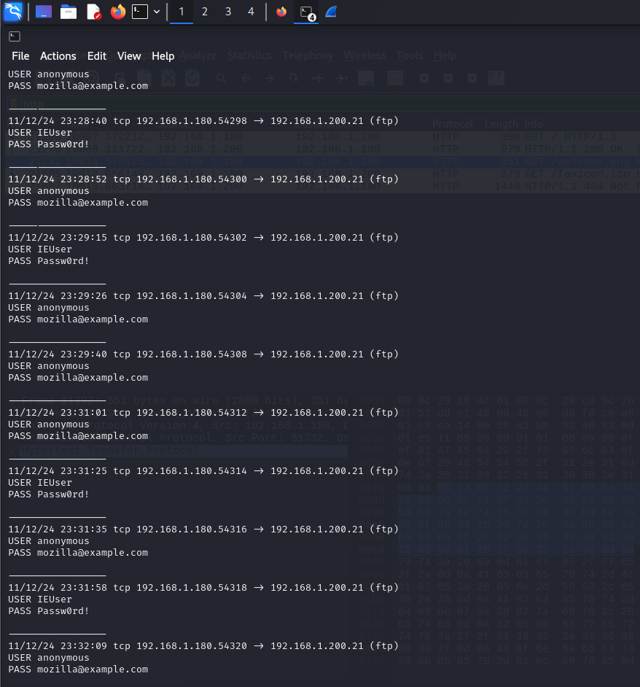

In this output, I am able to see date and time, type of connection, the packet source and destination including their ports for each they are using. Additionally, we can see type of service used as it shows it is FTP service. It also has sent default ones also.

1. Explain how a DDoS attack differs from a DoS attack.

When attacker plan to lead a network or website unavailable by overwhelming it with directing excessive traffic or data requests towards it by only one source, we will call it DoS or Denial of Service.

On the other hand , when we have got targeted network or website flooded with traffic directed from multiple sources, we call it DDoS or Distributed Denial of Service).

**Activity 7: Attacking Metasploitable-2**

2.8 Carry out the activities in the seventh set of lab notes for this unit to perform a Samba Command Execution attack on the Metasploitable-2 system.

100

1. Provide a screenshot of the output of the nmap command you ran on your Metasploitable-2 system. Please make sure that you include your name and student number on the image.

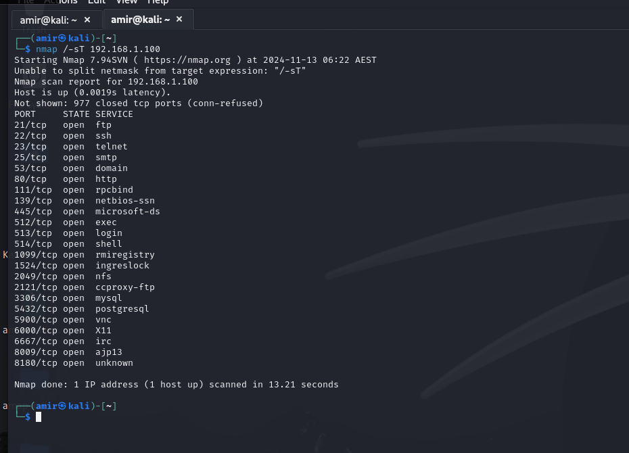

1. Provide a screenshot of the options required for the usermap_script exploit.

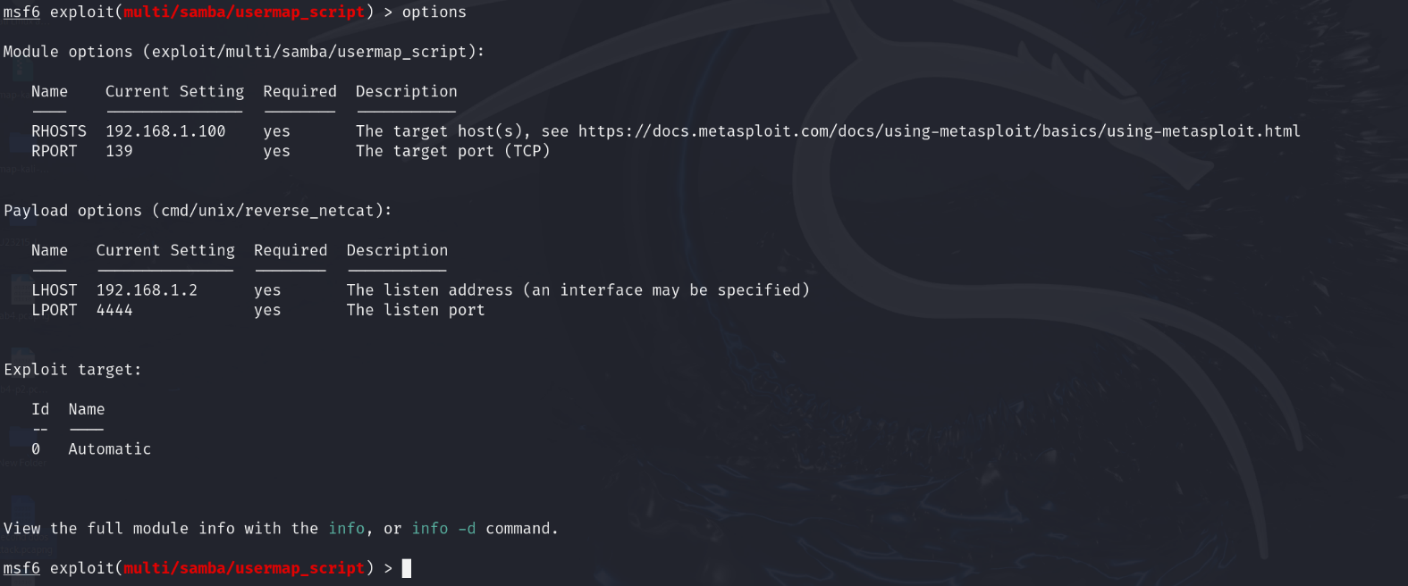

1. Provide a screenshot of the shell obtained by exploiting the samba vulnerability on the Metasploitable-2 system.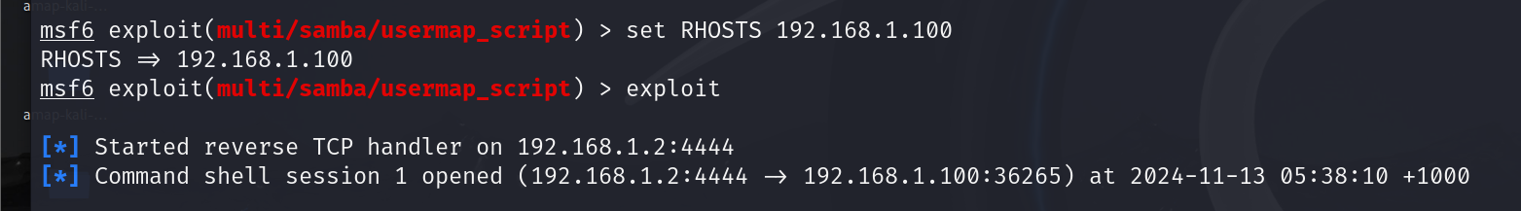

**PART 3 – Scenario 2: Demonstrate ethical hacking principles and procedures**

In this section of the portfolio, you need to demonstrate ethical hacking by detecting security vulnerabilities that a hacker could use to gain unauthorised access. You will also identify a number of mitigation strategies that could be used.

**TASK 1 Ethical hacking information gathering stage**

* 1. Using resources on the web or in journals, find three Trojans, Viruses, or Worms that spread in the last 90 days.

You may find that <https://www.akamai.com/security-research> and Microsoft’s Security Intelligence Service at <https://www.microsoft.com/en-us/wdsi/threats> helpful in this section.

**Clop Ransomware**: There was a ransomware which is being called Clop Ransomware. This ransomware is able to after getting to the target point, encrypts files and offers their own ransom key to unlock them after getting paid. It has been mentioned that this ransomware has been designed to target entire networks, instead of not attacking just individual devices.

**Cyborg Ransomware**: It is a ransomware which make it self available to the target as an urgent Windows updates. Then it will (as its usual ransomware habit ) encrypt files and then offers ransom key to unlock it after payment. It has been mentioned that most victims received it via email attachments.

**Zeus Gameover**: It is a Trojan that has reported to target sensitive bank account details and possible funds at each. This trojan has been said that doesn't necessarily needs a centralized Command and Control server for operation, leading defenders to a much complex detection process and then processes to make it stop.

3.2 Explain at least three (3) legal implications of illegal hacking and their consequences. Please refer to Australian Cyber Crime legislation when answering this question.

I found the Unauthorized Access in the Section478.1 of the Criminal Code Act 1995. This law has stated that it is illegal to attempt to gain access to a computer system without authorization. You can end up facing imprisonment for up to 2 years.

Moreover, I found Computer-Related Fraud in the section 477.4 of the Criminal Code Act 1995. IN this mentioned law, it is trying to address fraud associated with computers, in scenarios such as stealig money or sensitive credentials by hacking. They have introduced penalties which can be imprisonment for up to 10 years.

Lastly, we have got Theft of Data mentioned in the section 132.1 of the Criminal Code Act 1995. In this law, it try to make clear that the theft of data from a computer system is a criminalized act which can result in imprisonment for up to 10 years which can be different on the severity of the offense.

3.3 Describe at least two (2) system hacking methodologies that can be used in ethical hacking activities in Task 2.

First one is fishing which is considered as a technique to be used for tricking individuals towards a situation where they will provide attacker sensitive information, such as credentials, or credit card details, by pretending to be a trustworthy source. Usually, we have got Ethical hackers implement phishing tools to test an organization's security, employees’ awareness and preparation to response to such attacks. We are able to simulate phishing emails along with social engineering to employees to see performances and then provide further training in order to enhance their awareness.

Second one is SQL Injection which can be used to insert malicious SQL statements into an entry field for execution. SQL injection can be used by Ethical hackers to test the security of web applications those operating with SQL directly or indirectly. So, we can check If the application is not able to properly sanitize inputs from users allowing the malicious code being executed. So Ethical hacker can see if real attackers can access to sensitive data, modifying database contents, or even further gaining administrative rights and then fix security bugs.

3.4 Describe the fundamentals of penetration testing.

1. Planning and then Reconnaissance

It would be the first step which dedicated for gather information about the target system. Ethical hackers are required to understand structure of target operation, potential entry points, technologies to use and possibility of damage to the target.

2. Scanning phase:

In this phase, ethical hackers are supposed to use scanning tools such as Nmap or Amap for targeted network or system for services being run and possible vulnerabilities associated with each one. So for network we have got identifying hosts, open sources and running services. After that we will be able to research on each one of them for vulnerabilities.

3. Gaining Access

Now we have done with planning and scanning, so we need to exploit previously discovered vulnerabilities to find access points to further implement one of techniques such as SQL injection or other methods. In this section, we can assure about range of potential damage in case of having vulnerabilities being exploited.

4. Maintaining Access gained

As the access gained, we as ethical hackers need to maintain our established session to stay on target system for an extended period necessary. Most often installing backdoors are considered to be a malicious activity but ethical hackers may use it as a method to maintain their connection to the target. We need to also maintain this access without being detected.

5. Covering tracks

So, we can expect that we were able to maintain our access, now it is time to make sure our attempts as the ethical hacker is hidden and they will not learn about our presence in same way as real attackers. We can achieve this by clearing logs, modifying timestamps, and eliminating any fingerprint left during our attack to prevent detection.

6. Reporting and Remediation

After all of mentioned testing phases, it is time for ethical hacker to prepare a detailed report outlining his findings including possible vulnerabilities, method used, and the potential impact each vulnerability may have. The report needs to include recommendations for fixing the vulnerabilities improving overall security. After this organizations can implement these recommendations.

3.5 Explain the process of footprinting an organisation’s computer system.

In the process of gathering information about a target organization’s computer system to identify, the first

step is footprinting to identify potential vulnerabilities. This can be done with direct and indirect interactions

with the target using Nmap, Amap and WHOIS.

1. Passive footprinting:

Footprinting can be carried out using passive footprinting where we will be able to gather lots of available

information in public without directly interacting with the target system by DNS information or platforms such

as WHOIS where we can find owner details, IP ranges, and more. We can also use some good tools to find

some map of target network facilities.

2. Active Footprinting

This can be done with ports and service scans, performing traceroute and lastly grabbing banners. We

Can achieve this by tools such as Nmap, Amap and python scripts.

There are more footprinting methods such as social engineering or email footprinting.

3.6 Describe at least two (2) enumeration methods that can be used to obtain usernames.

**1. NetBIOS Enumeration**

It is being used to gather information from windows-based systems. Attackers use tools like nbtstat to get

NetBIOS name tables and service records, which can reveal usernames and other network resources.

**2. LDAP Enumeration**

It stands for Lightweight Directory Access Protocol (LDAP) enumeration is implemented to interact with

directory devices, such as Microsoft Active Directory in order to retrieve detailed information about users

and other objects in other directories. Its example usage guide is using ldapsearch and then you can modify

it more specific.

**TASK 2 – Demonstrate ethical hacking**

3.7 Use the industry standard lab provided by the teacher to perform a vulnerability assessment. Gather as much information as possible about the target network. Provide screenshots of the process.

1. Describe the ethical hacking process and procedures you have used

1. Planning

First we started with defining our objectives and gathering information.

2. Scanning:

Then we started with Network Scanning and learning about vulnerabilities using Nmap and Amap. We scanned open ports and active services with details.

3. Gaining access:

We exploit vulnerabilities found in last step and then establish access to the target or target’s traffic.

4. Maintaining access:

We assure current connection and also develop our roots to maintain access.

5.Reporting

We were asked to make reports and then document finding and discoveries. Further, we put our recommendations.

1. Outline and demonstrate at least two (2) basic troubleshooting procedures

1.Network connectivity:

> Ping test

> Traceroute

2. Service availability issues

> netstsrt

> Restart Services by systemctl on Linux

1. Outline and demonstrate the enumeration techniques you used

I used

Nmap -sV <target IP>

Nmap -O <target IP>

Nmap -A <target IP>

Nmap -F <target IP>

Nmap -sT <target IP>

1. Outline the footprinting information you have gathered from the system

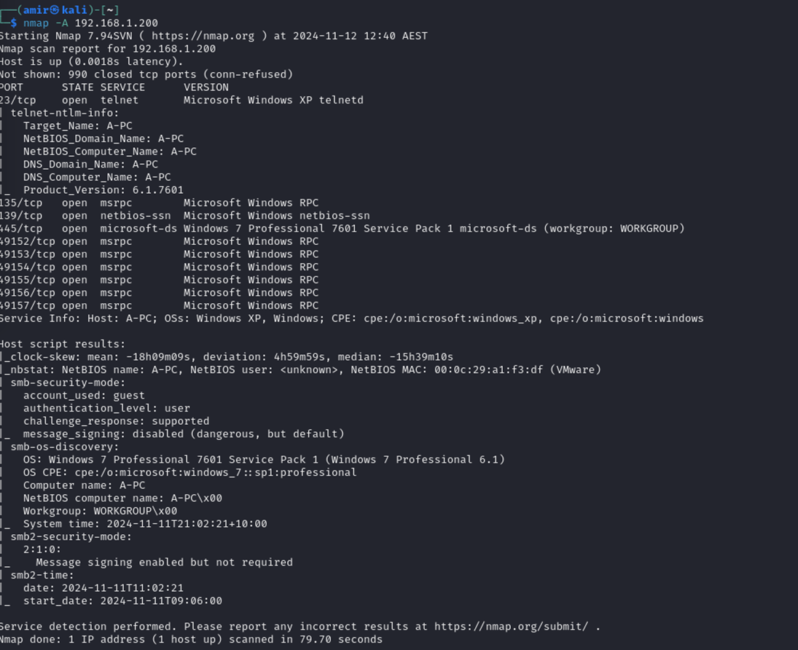







1. Identify the tools that were used to port scan the network

We used Nmap and Amap , specially Amap -B for getting banner of that port.



1. Explain what CVEs are and how they can be used in this activity.

First of all, we are supposed to find out what does CVE stands for. CVE stands common vulnerabilities and Exposeres. As we find about operation system and services being used, we usually tend to learn about common vulnerabilities associated with our findings. In this case, we are able to find resources on public about bugs of services or any special matters found by someone else in relation to that service or that port. Usually we receive CVE in classified tables if we attend to a good source where each CVE has got its own unique identifier aiding IT professionals to work with these vulnerabilities in more convenient and efficient way.

In our activity as an ethical hacker, I do believe we can use it for vulnerabilities identification, prioritizing our actions, structure our possible responses, and enhance our current cyber defence strategies.

3.8 Provide a summary of WLAN hardware/software vulnerabilities and explain how the organisation has addressed these issues. Explain how leaving the WPS ON on a wireless router could be exploited.   
WLAN stands for Wireless local Area Network, and its hardware and software vulnerabilities are how it weak and has security gaps which can be possibly exploited by attackers to gain unauthorized access, disrupt services, or further steal important data.

Organization can address these issues through establishing WLAN by Strong Passwords, having regular updates, using encryption, monitoring network, and implementing physical security.

Exploiting WPS ON

I do believe leaving WPS enabled on a router which is wireless can possibly be in danger of WPS PIN attack if not keep secured. WPS is believed to simplify the process of connection not forcing user to use manually entering log password method. Vulnerabilities for WPS can be made by Brute Force attacks, Physical access, and DNS Spoofing.

3.9 List two previously known zero-day attacks on application layer and explain the potential vulnerabilities and mitigation plans. Review the relevant available policies to minimise the identified application layer vulnerabilities.

1. SQL Injection Attack on Microsoft SQL Server happened 2002:

Vulnerabilities: This attack exploited a zero-day vulnerability in Microsoft SQL Server 2002 which allowed

attackers to execute arbitrary code on the server by injecting malicious SQL queries.

Mitigation plan used: Microsoft released a patch to fix the vulnerability and also suggest all users apply the

patch immediately. They also made all their developers to use parameterized queries and prevent this type

of attack by input validation.

2. Adobe Flash Player Zero-Day Vulnerability (2015):

Vulnerability: Attackers exploited a zero-day vulnerability in Adobe Flash Player to execute remote code on

target system. So they were able to use this vulnerability to gain unauthorized access to systems.

Mitigation plan used: Adobe decided to release an emergency update to address the vulnerability and ask

All users to update their Flash Player as soon as possible.

Policies to Minimize Application layer vulnerabilities

1. Regular security Audits and Code Reviews

2. Secure Coding Practices

3. Patch Management

4. Access control

5. Employee Training

3.10 Using the knowledge gained from this course and other resources, develop a strategy specifically for securing the organisation’s web server. This strategy should include securing the server itself as well as securing the network from the server.

Strategy to implement for securing the Organization’s Web Server

Securing the Web server

1. Server Configuration:

We are supposed to regularly update and patch the operating system to fix found vulnerabilities. We are

supposed to disable unnecessary services or ports to reduce the attack surface.

When we are configuring the server, we need to use strong and unique passwords for all accounts and also

require everybody login using multi-factor authentication (MFA) for accessing their accounts. We also need

to implement the principle such as least privilege where everyone has got classified access based on their

needs.

2. Web Server Software:

We need to keep our web server software updated with recent security patches. We need to securely

configure web server in a way to minimize information leakage. We also need to disable directory listing,

which will prevent others learn about server’s signature and restrict their access to sensitive files.

3. Application Security:

We are supposed to validate and sanitize user inputs to prevent SQL injection, XSS, and other attacks

which are input based. So, we need follow secure coding practices and at the same time suggest everyone

do the same.

4. Logging and Monitoring:

We are able to implement log management to supervise and capture access logs, error logs, and other

similar events. Using this we can find suspicious activities. So, it is possible to deploy an IDS to detect and

get alarms on potential intrusion attempts.

Securing the network from the server

1. Networking segmentation:

We need to put web server in a demilitarized zone to isolate it in the internal network.

2. We are supposed to have secure communication over network between server and other interfaces by

implementing encryption.

3. Firewall and IDS

We can implement network firewall to control incoming and outgoing traffic to and from web server. We can

configure firewall in way just allowing necessary traffic.

4.Backup and Recovery:

We can perform regular backups of our data and web server to assure we can restore our data in case of

data lose. Furthermore, we can develop and maintain a recovery plan to help us in data restoring process.

3.11 Explain what heuristic-based string analysis is and identify the toolsets that could be used in this scenario to determine vulnerability to specific threats.

When we need to identify potential threats by studying the behavior of strings within files or programs, we use a technique called Heuristic-based string analysis. There are also traditional methods where they used to rely on signature-based detection, and focusing on comparing known attack patterns. But heuristic analysis is being conducted by looking for suspicious behaviors or characteristics that are mostly found in malware and other threats.

I do believe that toolsets such as Nikto and Wireshark can be helpful in this scenario (as we have tested Wireshark in this scenario.)

3.12 Using the information gathered from the vulnerability research, identify at least three (3) security vulnerabilities. For each vulnerability, outline appropriate mitigation strategies.

|  |  |
| --- | --- |
| Vulnerability Research of Organisation <<name>> | |
| VULNERABILITY | PROPOSED MITIGATION STRATEGIES |
| Telnet port 23 | Disabling it, using encryption, monitoring access |
| Ssh port 22 | enforcing strong passwords, enabling public key authentication , regular updating software, limiting access. |
| SMB 139/445 | Disabling it, patch and update, defining good rules on the firewall, segmenting network, using strong authentication |

**PART 4 – Scripting for cybersecurity environments using Python**

* 1. The following Python script pings each host on a given network twice. Modify the script to only output hosts that are up/active.

**# Script to ping all IP addresses in a /24 subnet**  
**import os**  
  
**network = input ("Enter first 3 numbers of IP network, e.g. 1.2.3: ")**  
**print(network)**  
  
**# Iterate over all usable IPs in this subnet**  
**for host in range (1, 254):**  
**print("Pinging " + network + "." + str(host))**  
**os.system("ping -c 2 " + network + "." + str(host))**

**Modified one:**

**import os**

**network = input("Enter first 3 numbers of IP network, e.g. 1.2.3: ")**

**print(network)**

**# Iterate over all usable IPs in this subnet**

**for host in range(198, 254):**

**# Form the full IP address to ping**

**ip = network + "." + str(host)**

**print("Pinging " + ip)**

**# Run the ping command and check the return code**

**response = os.system(f"ping -c 2 -W 1 {ip} > /dev/null 2>&1")**

**# If the return code is 0, the host is up (active)**

**if response == 0:**

**print(f"{ip} is up.")**

* 1. Write a program to perform vulnerability research on the associated network.

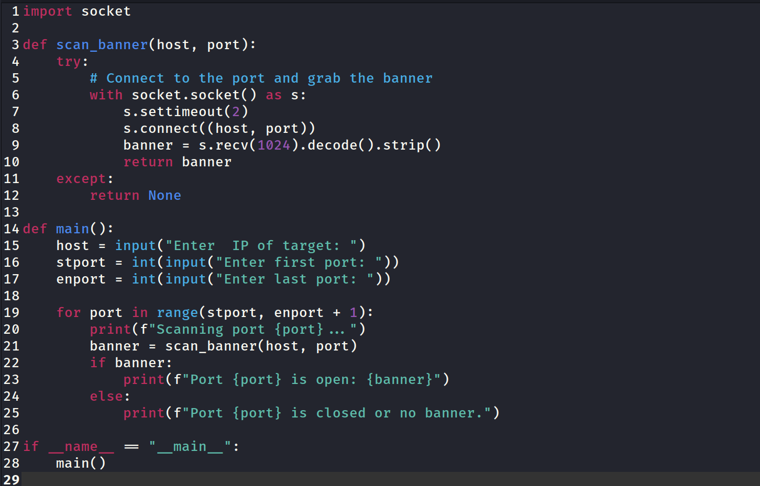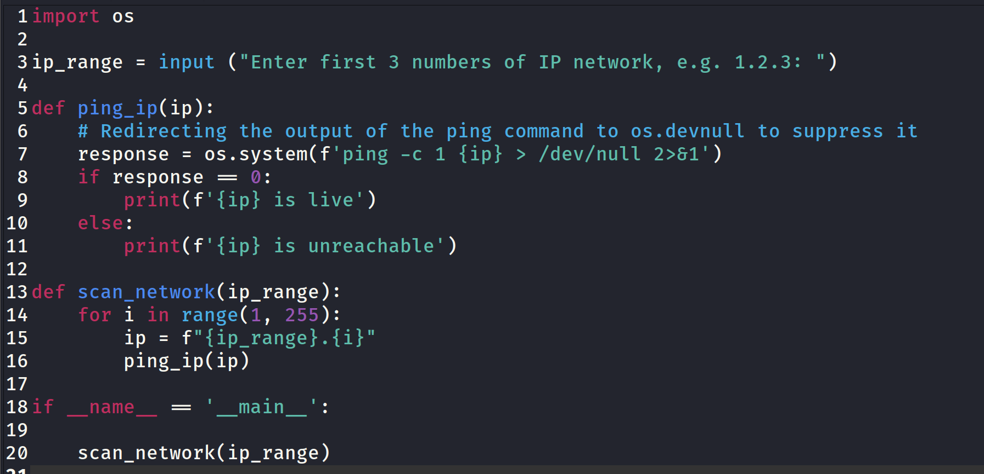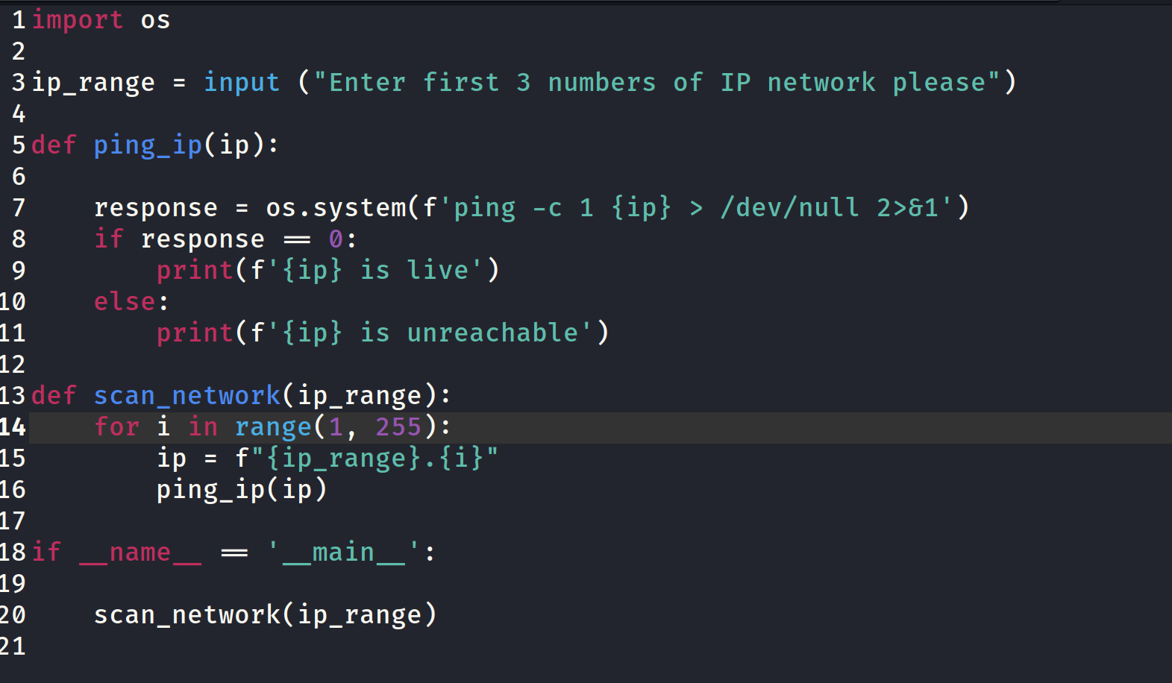

* 1. Write another program to retrieve information from one of the open ports you identified earlier. Use the appropriate protocols associated with the port to access it.  
     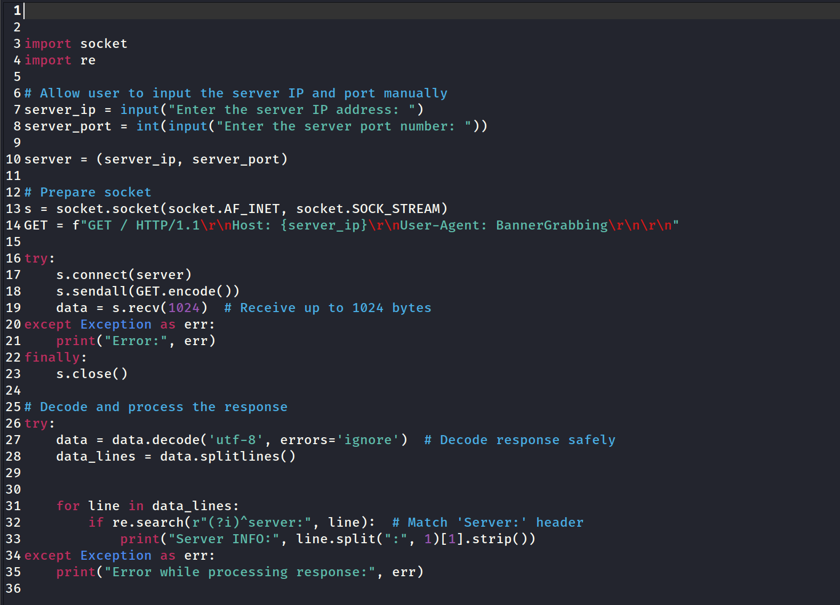
  2. Identify three (3) third-party Python libraries for ethical hacking. For each library, provide a description and describe its best security features and suitability.

|  |  |  |  |
| --- | --- | --- | --- |
| Third-party Python Libraries for Ethical Hacking | | | |
| **LIBRARY** | **DESCRIPTION** | **FEATURES** | **SUITABLE for** |
| Scapy | A packet manipulation tool for network attacks | It has got abilities such as Packet sniffing, packet forging, network scanning, and more. | Performing network security tests |
| Nikto | A web server scanner which is able to perform comprehensive tests on web servers | It has Tests which are able to detect over 6700 potentially dangerous files/CGIs, SSL/TLS vulnerabilities | Performing web application security scans |
| SQLMap | An tool which is open-source for identifying and exploiting SQL injection vulnerabilities | It can benefit us by automate process for the detection and exploitation of SQL injection flaws | Performing Database security scans |

**PART 5 – Contingency task**

5.1 Assume that your organisation has a cyber security contingency plan based on the following areas:

* Restoring systems and data using alternate equipment/tools
* Capability to perform basic tasks manually for short periods of time (while recovering from an attack)
* Recovery and backup of systems and data to an alternate site/location
* Identified impact levels for implementing contingency plan controls.

Explain the process that should be followed in the event that recovery and backup of systems and data to an alternate site/location fails.

When there is an event occurs and we needed to have our systems recovered using backups of their systems and data to an alternate location which is failed, we are supposed to start a process to mitigate damage and then restore normal operations. I have list them below:

1. Alert Incident Response Team (IRT**):**
   * First of all, we immediately need to notify the IRT to take control of happened situation and begin the contingency protocol.
2. Assess the Situation:
   * Then we are supposed to perform several assessments to find an understanding of the scope and scale of the occurred failure. And then we need to determine which systems and data are affected here. Further, based on the findings we can prioritize them.
3. Starting Manual Operations:
   * As usual operation has failed, we are supposed to implement our manual processes to continue critical operations. As we are utilizing new processes, staff should be trained to perform usual tasks without relying on failed automated systems.
4. Communication Plan:
   * After the failure and implementing manual operation, we need to notify all stakeholders, including employees, customers, and partners, about the failure occurred and the steps being taken now. We need to follow our predefined communication policy to assure consistent and accurate messaging.
5. Deploy Alternate Recovery Solutions:
   * If the primary alternate site/location failed, it is time to check for activating any secondary or tertiary backup sites we have got that have been identified in the contingency plan. If there we have got no additional physical sites, sometimes cloud-based recovery options or external data recovery services can be beneficial.
6. Restore from Recognized Safe Backups:
   * We need to Identify the most recent safe and successful backup of critical systems and data. We need to prioritize restoration processes and start with mention backups. We need to ensure about integrity of the backup data prior to restoration.
7. Enhanced Security Measures:
   * We need to enhance our monitoring and security measures to prevent further attacks or data loss. Moreover, we can review and update firewalls, intrusion detection systems, and access controls we have got.
8. Continuous Monitoring and Evaluation:
   * We need to have continuously supervise on the ongoing recovery process to ensure systems are being restored correctly after end of the process. We can have evaluation of the effectiveness of this process and make necessary adjustments for future.
9. Post-Incident Review:
   * Once we have again the systems back online, we need to conduct a post-incident review to if anything had gone wrong and how the response can be enhanced. We need to document lessons learned from this and update our contingency plan based on it.
10. Ongoing Training and Drills:
    * We need to assure that all staff are trained on updated contingency procedures and regularly can receive trainings to prepare for potential failures in future.

**End of Assessment Task**